## Quota allocation policies in U.S. federal fisheries management and implications for climate resilience

Christopher M. Free1,2*, Zoë J. Kitchel3, Matthew Seeley4, Allison Shields4

1 Marine Science Institute, University of California, Santa Barbara, Santa Barbara, CA, 93106, USA

2 Bren School of Environmental Science and Management, University of California, Santa Barbara, Santa Barbara, CA, 93106, USA

3 Vantuna Research Group, Occidental College, Los Angeles, CA, 90041, USA

4 Environmental Defense Fund

**\* Corresponding author:** 2400 Bren Hall, Bren School of Environmental Science and Management, University of California, Santa Barbara, Santa Barbara, CA, 93106, USA; [cfree14@gmail.com](mailto:cfree14@gmail.com)

### Abstract

Quota allocation, which divides fishing catch or effort between regions, sectors, subsectors, individuals, and/or seasons, is one of the most important and contentious processes in fisheries management. Quota allocation policies often aim to advance fairness and equity goals by preserving levels of historical participation and access. However, this reliance on historical patterns makes allocation policies vulnerable to climate change, which is shifting the accessibility of marine resources among historical and new participants. Despite this, there is little guidance on best practices for adapting allocation policies to climate change. In the United States, regional flexibility to design locally relevant allocation policies has innovated a diversity of approaches that can be studied for their climate vulnerability and/or adaptivity. Here, we synthesize the diverse allocation policies used to manage U.S. federal fisheries (491 stocks, 42 management plans, 8 regions) and evaluate the vulnerability of these policies to climate change. We find that allocation policies are used to manage 46% of federally managed stocks. Although most policies are based on historical catch, many include features that promote climate adaptiveness, including the ability to transfer quota between states, sectors, or individuals; adjustment of allocations based on current resource distribution or abundance; set aside of quota to support research and experimentation; and gradual phase in of policy changes. Ultimately, we provide eight transferable recommendations for improving the ability for allocation policies to advance their fairness and equity goals under climate change.

**Keywords:** adaptive management, catch allocations, catch shares, climate change, equity, fairness

**Short title:** Quota allocation and climate resilience

### 1. Introduction

Climate change is shifting the abundance, distribution, and phenology of harvested marine resources, which is challenging the ability for managers to maintain the conservation and socioeconomic goals set for global fisheries (IPCC, 2019). To achieve conservation goals, managers must establish catch or effort controls that maintain sustainability as stocks experience climate-driven shifts in their productivity and distribution (Gaines et al., 2018). To meet socioeconomic goals, managers must further ensure that access to shifting resources remains fair and equitable despite changing oceanographic conditions (Tokunaga et al., 2023). This can be achieved through a combination of management policies ranging from permitting, which governs who can access resources, to quota allocation, which governs how much catch or effort is available to those with permitted access (Ojea et al., 2017).

Quota allocation is arguably one of the most important and contentious processes in fisheries management as it dictates how access is shared among fishery participants. While the establishment of catch limits is a largely objective and scientific process (Punt, 2010), decisions about how to distribute the resulting quota is more subjective and depends on complex socioeconomic considerations (Morrison & Scott, 2014). Quota allocations are often made between jurisdictions (e.g., international, regional, state), sectors (e.g., commercial, recreational, tribal, research), subsectors (e.g., gillnets, longlines), individuals (e.g., catch shares), and seasons. Allocations are often based on relative levels of historical catch or effort as they frequently aim to maintain proportional access for fishing communities historically dependent on fishery resources (Cox, 2009; FLSF, 2010; Lynham, 2014). However, climate change is causing rapid departures from historical conditions, which can lead to unfair, inequitable, and inefficient resource use when access is based solely on historical dynamics (Palacios-Abrantes et al., 2020, 2023; Pinsky et al., 2018; Vogel et al., 2024). As a result, fisheries managers will need to develop procedures for adapting quota allocation policies so that they continue to advance their fairness and equity objectives despite changing ocean conditions.

The challenge posed by climate change is arguably most direct for spatial quota allocation policies as climate change will rearrange the distribution of stocks. Spatial allocations, which allocate quota across different management areas (e.g., countries, regions, states), generally aim to ensure that harvest is proportional to either the biological availability of the resource or the historical dependence of fishing communities on the resource. However, climate-driven shifts in the distribution of marine species imply that historical benchmarks used to set spatial allocations will not reflect future distributions (Palacios-Abrantes et al., 2020, 2023; Pinsky et al., 2018). This can present a number of conflicts, inequities, and inefficiencies. For example, if allocations are not updated to reflect shifted distributions, some fishing communities may be unable to capitalize on increases in local availability, which would be especially challenging if other species in their portfolio are negatively impacted by climate change (Cline et al., 2017; Samhouri et al., 2024). Worse still, fisheries may be at increased risk of closure if they are unable to avoid a newly abundant resource for which they have little allocation. Furthermore, vessels from a region maintaining its allocation based on historical distributions may need to travel farther to fulfill their quota (Young et al., 2019), increasing costs, safety concerns, and carbon emissions (Papaioannou et al., 2021; Scherrer et al., 2024). Thus, there is an urgent need to develop frameworks for adapting spatial allocation policies to shifting species distributions resulting from climate change.

The allocation of quota between and within fishing sectors has less direct though still important connections to climate change. Allocations among sectors guarantee access for diverse fishery participants and, like spatial allocations, are often allocated in proportion to historical dependence (Edwards, 1990). However, climate change is pushing resources deeper (Pinsky et al., 2013), which could challenge the ability for nearshore recreational fisheries and/or small-scale commercial vessels to attain their historical quotas (Papaioannou et al., 2021). Allocations among gears within a sector similarly protect diverse access, but can also be used to limit effort by gears with larger bycatch or habitat impacts (Jenkins & Garrison, 2013). However, because climate change is also altering bycatch patterns (Free, Anderson, et al., 2023), allocations based solely on historical landings could exacerbate bycatch issues. Finally, allocations between individuals or groups (e.g., fishing cooperatives or communities), often termed “catch shares,” can improve safety-at-sea by slowing the race to fish (Birkenbach et al., 2017) and improve sustainability by better aligning conservation and economic incentives (e.g., catch shares only hold value if a stock is healthy and the quota is large) (Costello et al., 2008). However, these policies are also largely based on historical catch patterns (Lynham, 2014), which makes them vulnerable to climate change (Tokunaga et al., 2023). Equity issues can arise as distribution shifts further the distance between the share owners and the resource (Edwards & Pinkerton, 2019). Furthermore, catch shares often lead to less diverse fishing portfolios (Holland et al., 2017), which can reduce resilience to climate change.

The laws governing U.S. federal fisheries management mandate that allocation policies be fair, equitable, and transparent, but gives regional managers immense flexibility in how they achieve these goals. The Magnuson-Stevens Fishery Conservation and Management Act, the primary legislation governing U.S. federal fisheries, provides ten National Standards to define management requirements, of which National Standard 4 directly relates to quota allocations (MSA, 2007). This provision specifies that allocations must be *“(1) fair and equitable to all such fishermen; (2) reasonably calculated to promote conservation; and (3) carried out in such manner that no particular individual, corporation, or other entity acquires an excessive share of such privileges”* (§ 600.325 National Standard 4—Allocations, 1998). Given the absence of feasible alternatives, both official guidance and adopted practices have generally aimed to be fair and equitable by maintaining historical access and harvests, though with additional considerations for new entrants, bycatch, economic efficiency, and other factors (Plummer et al., 2012). This openness gives the eight regional Fishery Management Councils (FMCs) (**Figure 1**) flexibility to design allocation policies tailored to their specific socioeconomic and ecological contexts. However, these approaches may have different strengths and weaknesses in their ability to fulfill National Standard 4 in maintaining fairness and equity under climate change.

In 2011, the U.S. National Marine Fisheries Service (NMFS) launched an effort to provide more detailed guidance on allocation, but these recommendations do not explicitly consider climate change impacts on U.S. fisheries (Lapointe, 2012). This process began with a review of the allocation policies used in U.S. federal fisheries management (Morrison & Scott, 2014; Plummer et al., 2012), which provided the context for subsequent guidance on criteria for triggering the review of allocation policies (Morrison, 2016a) and for factors to consider when conducting such reviews (Morrison, 2016b, 2017c). This guidance, which was cemented as national policy between 2016 and 2017 (Morrison, 2017b, 2017a), calls for an adaptive process for evaluating whether allocations are meeting management objectives and for adjusting allocations when objectives are not being met. These policies suggest that the review of an allocation policy could be triggered based on a tracked performance indicator, public input, or at regular time intervals. They also highlight that the ability to transfer quota between states, sectors, or individuals offers in-season adaptability. While both of these guidelines provide some inherent climate resilience, the connection to climate change is not explicit, and more guidance on strategies for climate-adaptive allocation policies is needed (US GAO, 2022).

In this paper, we synthesize the diverse allocation policies used to manage U.S. federal fisheries, evaluate the vulnerability or adaptivity of these policies to climate change, and provide recommendations for increasing the climate-adaptiveness of allocation policies. We begin by cataloging the allocation policies of 491 stocks managed by the 42 fisheries management plans developed by the 8 FMCs into a standardized database. This provides a platform for understanding the myriad of allocation approaches taken across the U.S. and for understanding how approaches differ by region. We then evaluate the vulnerability or adaptiveness of these policies to climate change and offer recommendations for increasing the ability for these policies to maintain equity and fairness under climate change. We draw these recommendations from best practices identified from both U.S. and international fisheries management. These recommendations provide a roadmap for any federal, state, or international fishery seeking to maintain the fairness and equity of their allocation policies under climate change.

### 2. Methods

#### 2.1 Systematic review of U.S. allocation policies

We inventoried the quota allocation policies currently implemented in U.S. federal fisheries management by reviewing all 42 Fishery Management Plans (FMPs; including 5 “Fishery Ecosystem Plans” or FEPs) and their associated amendments for descriptions of their allocation policies (**Table S1**). We prepared a brief summary of each allocation policy to provide a clear and concise description of these often complex policies using a consistent structure and terminology. Each summary describes the types of allocation policies used, the recipients of quota, the amount of quota allocated to each recipient, and the basis for the allocation amounts. When necessary, we reviewed documents in addition to the FMPs, FEPs, and amendments to gather this information (e.g., Environmental Impact Statements and Final Rulings in the Federal Register). In some cases, we also summarized the history of changes made to the allocation policy and the motivation for these changes. These historical adjustments provide critical insights into considerations and pathways for adapting allocation policies in response to climate change. However, we only recorded this information when it was readily accessible to keep the scope of our review manageable. The summaries are provided in **Appendix A**.

We used the summaries to develop a database describing the allocation policies used to manage 491 federally managed marine fish and invertebrate stocks with a common set of characteristics (**Figure 1; Table S1**). The database summarizes: (1) basic information on each stock (i.e., FMC, management plan, species group); (2) the allocation policy types used to manage the stock; and (3) traits of each of the implemented allocation policy types. We classified allocation policy types into five categories: spatial, sector-based (among sectors), subsector-based (within a sector), catch shares, or seasonal (**Figures 2 & 3**). A spatial policy allocates quota among countries, states, or other management areas. A sector-based policy allocates quota among commercial, recreational, tribal, and research sectors. A subsector-based policy allocates quota to groups (e.g., gear types, vessel size tiers, product end uses) within one of these sectors. A seasonal policy allocates quota across different seasons. We use “catch shares” as a general term for allocation policies that distribute quota among individual fishermen, groups of fishermen, cooperatives, fishing communities, or other entities, which include individual fishing quotas (IFQs), territorial use rights for fisheries (TURFs), and limited access privilege programs (LAPPs). We excluded limited access permits that were not specifically associated with an effort or catch allocation. We recorded the basis for each allocation type, i.e., whether the allocation amount was derived based on historical catch or effort, recent catch or effort, recent resource distributions, equal catch or effort, an auction, or a combination of approaches. We also recorded the number and identity of geographies, sectors, or subsectors receiving allocations. The structure of the database is illustrated in **Table S2**.

We confirmed the accuracy of our summaries and database by comparing them to information synthesized in other relevant but less comprehensive reports (FLSF, 2010; Morrison & Scott, 2014; Plummer et al., 2012; Tokunaga et al., 2023) (**Figure S1 & S2**) and by asking FMC staff members with expert knowledge of allocation policies to review the summaries. We received reviews from FMC staff members for 34 of 42 FMPs (81%).

#### 2.2 Brief review of international allocation policies

To broaden our search for climate-adaptive quota allocation policies, we supplemented our systematic review of allocation policies used in U.S. federal fisheries management with a brief review of allocation policies used in other fisheries around the world. We focused this review on international fisheries whose allocation policies have been well summarized in a few key sources (i.e., where an exhaustive review was not required to generate a comprehensive understanding of each entity’s quota allocation policies). The selected vignettes and their key references are as follows: Europe (Carpenter & Williams, 2021; Scholaert, 2023; Seas At Risk, 2024), Australia (Knuckey et al., 2019; Mazur et al., 2020; McShane et al., 2021), New Zealand (Lock & Leslie, 2007), and the Parties to the Nauru Agreement (PNA) for Pacific skipjack tuna (*Katsuwonus pelamis*, Scombridae) (Aqorau et al., 2018). The successes and failures of these allocation policies are highly instructive to the U.S. and any other country that allocates quota in the context of rapid environmental change.

#### 2.3 Identifying best practices for climate-adaptive allocation policies

We used our systematic review of U.S. allocation policies and brief review of international policies to identify best practices for climate-adaptive allocation policies. We identify these practices as policies that either (1) directly consider climate change in the allocation of quota or (2) support the adaptive management of allocation policies, which indirectly but effectively bolsters management responsiveness to climate change. Adaptive management views management strategies as experiments that can be iteratively studied and adjusted in response to outcomes (Walters, 1986). By periodically reviewing and updating management strategies to ensure that management objectives are being met (Bahri et al., 2021; Walters & Hilborn, 1976), adaptive management provides inherent climate resilience by ensuring that management is responsive to changing conditions, especially under high uncertainty (Bahri et al., 2021). As a result, the United Nations Food and Agricultural Organization (FAO) identifies adaptive management as a *“*fundamental principle of climate-adaptive management” and highlights flexible management that is robust to uncertainty as especially valuable (Bahri et al., 2021). Adaptive management is often implemented through a cyclic process that can be divided into the following stages: (1) planning, (2) doing, (3) evaluating and learning, and (4) adjusting (Jones, 2005). We organized the identified best practices for climate-adaptive allocation within this cyclic adaptive management framework.

### 3. Allocation policies in U.S. fisheries

#### 3.1. Overview

A large portion (46%; 228 of 491 stocks) of federally managed fish and invertebrate stocks are managed using some form of quota allocation policy (**Figure 3**). Sector-based allocation policies are most common, followed by catch shares, subsector-based, spatial, and seasonal policies. Allocation policies are especially commonly used by the U.S. East Coast FMCs (i.e., the Mid-Atlantic, South Atlantic, and New England, in order of decreasing frequency,).

#### 3.2. Spatial allocations

Spatial allocation policies are used in the management of 12% (n=57 stocks) of federally managed stocks (**Figure 3**). All regions except for the South Atlantic, Gulf of Mexico, and Caribbean employ country-based spatial allocations of transnational stocks **(Figure 4A)**. The lack of country-based allocations in the South Atlantic is likely due to its distance from an international border (**Figure 1**). The lack of country-based allocations in the Gulf of Mexico, which neighbors Mexico, and in the Caribbean, which neighbors many island nations, is likely due to (1) a lack of data to quantify the transnational distribution of resources and (2) the regional prevalence of reef fish, which exhibit higher site fidelity and more granular population structure than other fish taxa (Biggs & Nemeth, 2016; Carson et al., 2011; Coleman et al., 1999). In the Pacific, country-based allocations for coastal pelagic species are based on fixed percentages (**Figure 4B**), despite awareness that these stocks experience dynamic shifts in distribution as a response to oceanographic conditions (Pozo Buil et al., 2021). In New England, country-based allocations for Eastern Georges Bank haddock (*Melanogrammus aeglefinus*, Gadidae), Atlantic cod (*Gadus morhua*, Gadidae), and yellowtail flounder (*Pleuronectes ferruginea*, Pleuronectidae) are jointly managed by the U.S. and Canada through the Transboundary Management Guidance Committee (TMGC). The TMGC determines annual allocations for all three stocks by combining both historical landings and current resource distribution according to fisheries independent trawl surveys (Andrushchenko et al., 2022). This approach is climate-adaptive because it incorporates information on recent distribution shifts. By retaining the influence of historical landings, it also balances current distributions with historical dependence. This policy was first implemented in 2003 weighing historical landings at 40% and current distribution at 60% and was annually adjusted in 5% increments until reaching the target 90% current distribution to 10% historical landings weighting in 2010 (Andrushchenko et al., 2022). Such gradual changes, termed “phase ins,” allow time for fleets to adapt to changes in their allocation, which presents a good practice for reducing socioeconomic impacts when changing fisheries policies (S. Cox et al., 2019).

The Mid-Atlantic and the Gulf of Mexico are the only regions to allocate quota among constituent states **(Figure 4A)**. The North Pacific likely lacks state-based allocations because Alaska is the only state in the region. The lack of state-based spatial allocations in the Pacific is likely because Pacific groundfish stocks are often assumed to have stock structure matching state boundaries and thus have state-specific catch limits (PFMC, 2023b). Although the Western Pacific and Caribbean regions have island territories similar to states (**Figure 1**), they do not use territorial allocations because catch limits are calculated at the island territory level, similar to the approach in the Pacific. Although state-based allocations for Mid-Atlantic bluefish (*Pomatomus saltatrix*, Pomatomidae) are fixed percentages (**Figure 4C**), they are transferable between states, which increases their adaptiveness to climate-driven shifts in distribution. In contrast, the state-based allocations for Mid-Atlantic black sea bass (*Centropristis striata*, Serranidae) and summer flounder (*Paralichthys dentatus*, Paralichthyidae) are dynamically updated, weighing both historical landings and current distribution or abundance. Specifically, when summer flounder abundance is below 9.55 million pounds, quota is allocated based on the default percentages (**Figure 4C**); when it is above this threshold, the excess quota is allocated in equal shares (with the exception of Maine, New Hampshire, and Delaware, which split 1% of the additional quota above 9.55 million pounds). Black sea bass allocations are even more spatially dynamic: 75% of the quota is allocated using the historical landings-based default percentages and the remaining 25% is regionally allocated based on regional biomass distributions estimated by the most recent stock assessment (**Figure 4C**).

Area allocations are the only spatial allocation strategy used in the South Atlantic and are also widely used in the North Pacific and New England (**Figure 4A**). In the South Atlantic, area allocations divide quota between (1) the Gulf of Mexico and South Atlantic for black grouper (*Mycteroperca* *bonaci*, Serranidae), yellowtail snapper (*Ocyurus chrysurus*, Lutjanidae), and mutton snapper (*Lutjanus analis*, Lutjanidae); (2) northern and southern zones for South Atlantic king mackerel (*Scomberomorus cavalla*, Scombridae) and (3) northern, southern, and western zones for Gulf of Mexico king mackerel (**Figure 4D**). In New England, Atlantic herring (*Clupea harengus*, Clupeidae) quota is allocated among statistical areas (**Figure 4D**) and Atlantic scallop (*Placopecten magellanicus*, Pectinidae) quota is allocated among “open access” and “specified access” areas. Finally, in the North Pacific, quota is allocated among various zones and statistical areas.

#### 3.3. Sector allocations

Sector allocations are used in the management of 27% (n=134 stocks) of federally managed stocks (**Figure 3**). The approach to allocating catch between commercial, recreational, tribal, and research sectors differs widely by region. In the South Atlantic, Gulf of Mexico, and Mid-Atlantic, which have the largest recreational fisheries of the eight management regions (NMFS, 2022) (**Figure 1**), allocations between commercial and recreational sectors are implemented as a fixed percentage of the total allowable catch, which is generally based on historical reference periods (**Figure 5AB**). The percentage and reference periods vary by region and stock. In a nationally unique example, the management of Mid-Atlantic bluefish allows for in-season quota transfers between the commercial and recreational sectors. In the Caribbean, there are no explicit allocations of quota between commercial and recreational sectors, but the use of a constant catch harvest control rule that sets catch limits for each sector based on landings during a historical reference period (Free, Mangin, et al., 2023) represents an implicit allocation policy, as the allocation of catch remains fixed based on historical precedent (**Figure 5C**). In the remaining regions with smaller recreational fisheries, allocations to the recreational fishery are largely done through “set asides,” which remove projections of the expected recreational catch from the total allowable catch and allocate the remainder to the commercial fishery. The only exceptions are for Gulf of Maine Atlantic cod (*Gadus morhua*, Gadidae) and haddock (*Melanogrammus aeglefinus*, Gadidae) in New England, which are allocated using fixed percentages (**Figure 5A**), and for Pacific salmon (*Oncorhynchus* spp., Salmonidae), which is allocated using policies that increase the percent allocation to recreational fisheries at low population sizes to ensure reasonable recreational fishing opportunities (**Figure 5D**). Allocations to tribal fisheries and research are also assigned through set asides. Allocations for research are common for the scientific surveys (e.g., bottom trawl surveys) that support stock assessments as well as for programs that support cooperative research (e.g., “exempted fishing permits” program or the “research set asides” program of the New England and Mid-Atlantic).

#### 3.4. Subsector allocations

Subsector, or within sector, allocations are used in the management of 15% (n=73 stocks) of federally managed stocks (**Figure 3**). They are especially widely used in the New England, North Pacific, and Pacific regions, which support a multitude of different fleets targeting diverse groundfish species (**Figures 3 & 6**). They are not used in the Western Pacific or Caribbean, potentially as a result of insufficient fleet-specific catch data. Subsector allocations are primarily used to divide catch within the commercial fishing sector (**Figure 6A**). Gulf of Mexico red snapper (*Lutjanus campechanus*, Lutjanidae), which allocates recreational catch between the for-hire (a.k.a., party boat, head boat, charter boat, 42.3%) and private fleets (57.7%), is the only stock managed using subsector allocations within the recreational sector. Commercial quota for Gulf of Alaska Pacific cod (*Gadus macrocephalus*, Gadidae) is divided between fifteen subsectors, the maximum number of divisions of any subsector-based allocation policy (**Figure 6B**). Within the commercial sector, subsector allocations are divided between fleets that differ in their: catch share program participation (16 stocks), gear type (e.g., longline, gillnet, trap; 16 stocks), end use of catch (e.g., bait or food; 6 stocks), target species (e.g., herring, non-herring; 3 stocks), and vessel tier (e.g., specialists vs. generalists; 2 stocks) (**Figure 6A**). Atlantic mackerel (*Scomber scombrus*, Scombridae) and golden tilefish (*Lopholatilus chamaeleonticeps*, Malacanthidae), both managed by the Mid-Atlantic FMC, are the only stocks for which quota is allocated among vessels exhibiting different “tiers” of participation or specialization in the fishery. The Northeast Skate Complex FMP, implemented in New England, allocates catch among vessels targeting skates for bait or for human consumption (“wing” fishery), and is the only FMP to allocate based on end use. The Northeast Multispecies FMP, also implemented in New England, is the only FMP to allocate catch among commercial fleets that do or do not participate in a catch share program.

#### 3.5. Catch share allocations

Catch shares are used in the management of 23% (n=111 stocks) of federally managed stocks (**Figure 3**). There are currently 18 catch share programs for federally managed species in the U.S. The first program (Mid-Atlantic: Surf Clam and Ocean Quahog) was implemented in 1990, and the most recent (North Pacific: Pacific Cod Trawl Cooperative Program) in 2024 (**Table S3; Figure 7**). Additionally, in 2000, scallop permit holders in Alaska formed a self-organized, voluntary catch share that is managed through the Weathervane Scallop Cooperative that we include in our analyses. Catch shares are most common in the North Pacific. Currently, neither the Caribbean nor the Western Pacific implement any catch share programs. Initial allocations are typically distributed to active participants in the fishery at the time of program implementation, and are based on best years of landings during a historical reference period (**Figure 7**). However, alternative allocation procedures exist. For example, the Atlantic Sea Scallops IFQ bases allocations on historical landings and vessel size. In the case of the voluntary scallop cooperative program in Alaska, allocations are negotiated on a yearly basis by participants. For highly self-regulated programs such as AI Pollock and Alaska CDQ, allocations are also negotiated internally. In some programs, participants transfer individual allowance (quota, catch history, etc.) to cooperatives or sectors (e.g., “potential sector contribution” for New England Multispecies) on either a mandatory or voluntary basis. Some programs, including the Bering Sea and Aleutian Islands Non-Pollock (Amendment 80) Cooperative Program and the U.S. Atlantic Bluefin Tuna Longline Individual Bluefin Quota Program, were implemented to manage bycatch of non-target species in a fishery.

Many of the catch share programs in the U.S. share characteristics common to these types of programs. New entrants are uncommon because of the high cost of entry (e.g., cost of buying or leasing quota on top of cost of vessel, gear, gas, etc.). Currently, most programs allow transfers of both quota shares (permanent sale) and annual allocations (temporary lease) among entities. However, quota share caps (holdings cap) and annual allocation caps (use caps) are commonly implemented to limit consolidation (Brinson & Thunberg, 2016). Transfers can act as a mechanism for entry to a fishery, but quota is often too expensive for entry to be feasible for early career fishermen (Holland et al., 2017). To combat this obstacle, programs such as the Gulf of Alaska’s Halibut and Sablefish IFQ’s Community Quota Entities rely on non-profits to buy quota, and lease it to community members, although these programs tend to be underutilized (Soliman, 2015). Although uncommon, adaptive catch share programs aim to facilitate new entrants, reduce the prevalence of absentee quota owners, and ensure allocation is representative of current species distributions and fishery activity (Stephen et al., 2019). For example, the West Coast Groundfish Trawl Catch Share Program sets aside 10% of quota to address issues common to catch share programs, but this reserve has consistently been passed-through to IFQ participants because the Pacific FMC has not yet identified ways to address issues with the set-aside quota (NOAA, 2014). Adaptive catch share programs can also allow management to reclaim and redistribute quota, which presents a potential mechanism for adaptively revising allocation policies to better achieve equity and fairness goals under climate change.

#### 3.6. Seasonal allocations

Seasonal quota allocations are only used to manage 7% (n=34 stocks) of federally managed stocks (**Figure 8**). Seasonal allocations are most common on the U.S. East Coast (**Figure 8**). On the West Coast, they are only used for Pacific sardine (*Sardinops sagax*, Alosidae) and select species managed by the Bering Sea-Aleutian Island and Gulf of Alaska Groundfish FMPs (not illustrated; percents unknown). Existing seasonal allocations are divided among quarters (e.g., New England silver and red hake), trimesters (e.g., Mid-Atlantic longfin inshore squid), or seasons (e.g., South Atlantic king mackerel) (**Figure 8**). In general, seasonal allocations are used to avoid catch limit overages and to curb the race to fish. A notable exception is the seasonal allocation policy for Atlantic herring (*Clupea harengus*, Clupeidae), which is used to ensure that the majority of catch comes when the demand for bait for the American lobster (*Homarus americanus*, Nephropidae) fishery is highest and the herring fishery is therefore most profitable. The Atlantic herring allocation policy is also noteworthy because of its flexibility, which makes it climate-adaptive. The policy is determined annually and can be allocated across bi-monthly, trimester, or seasonal periods based on the recommendations of constituent states.

### 4. Allocation policies in international fisheries

#### 4.1. Europe

The Common Fisheries Policy (CFP), which governs fisheries management in the European Union (EU), allocates EU Member States a fixed percentage of the annual total allowable catch (TAC) of more than 200 stocks based on each state’s historical (1973-1978) catch (Carpenter & Williams, 2021). This policy aims to provide so-called “relative stability” for each Member State. Although the CFP provides guidance on how Member States should further distribute their allocated quota among subnational fleets, it awards States ultimate authority over these distributions. Specifically, Article 16 of the CFP states that “*each Member State shall decide how the fishing opportunities that are allocated to it…may be allocated to vessels flying its flag*” and Article 17 suggests that allocations use *“transparent and objective criteria including those of an environmental, social and economic nature, [which could include] the impact of fishing on the environment, the history of compliance, the contribution to the local economy, and historic catch levels”* (Carpenter & Williams, 2021). However, to date, the vast majority of subnational allocations have been based on historical catches and have rarely considered other social, economic, or environmental criteria (Carpenter & Williams, 2021; Scholaert, 2023; Seas At Risk, 2024). As a result, two-thirds of consulted stakeholders report that they do not think that Member States implement Article 17 in a satisfactory manner (Posti & Rudh, 2022). The most common reason for allocations to deviate from historical catches has been to support small-scale fishing opportunities or to support low impact fishing gears, which often go hand in hand (Seas At Risk, 2024). For example, the Swedish scampi (*Nephrops norvegicus*, Nephropidae) fishery incentivizes the use of lower impact creel traps over higher impact bottom trawls, by allocating more quota to small-scale creel fishers than would be awarded based on historical catch proportions. In a few cases, allocations have been used to encourage new entrants. For example, Ireland’s coastal multispecies fishery and Malta’s bluefin tuna (*Thunnus thynnus*, Scombridae) fishery reserves quota for fishermen without previous participation and catch records. Finally, Greece’s bluefin tuna fishery allocates quota for vulnerable populations, including fishermen with island residency, disabled children, small vessels, or small crews. These examples, though exceptions to the rule, illustrate the broad array of ecological, economic, and social objectives that quota allocation can be used to support.

#### 4.2. Australia

Australian allocation policies vary widely across subnational jurisdictions (states and territories). In 2010, the Australian Fisheries Managers Forum identified allocation as one the most important policy issues to address (AFMF, 2010). In response, the Fisheries Research and Development Corporation formed a working group to synthesize existing allocation policies and provide recommendations for reform (FRDC, 2012). The working group report found that only two of the country’s six coastal jurisdictions (Western Australia and South Australia) had clear policies for guiding allocation decisions (Neville, 2012). In 2016, another government report concluded that *“the basis for allocation is often opaque, uncertain, and/or of questionable efficiency”* and that *“stated policy objectives include multiple and sometimes competing goals that often provide limited guidance on how judgements should be made”* (Productivity Commission, 2016). Since these reports, Queensland, New South Wales, and Northern Territory have written allocation policies but have yet to implement them. Victoria and Tasmania have yet to write an allocation policy (Knuckey et al., 2019). In Western Australia and South Australia, sector allocations are made between commercial, recreational, and Indigenous fleets, and have been primarily based on historical catch, despite the fact that these allocation plans recognize the importance of other social, cultural, and economic values in making allocation decisions (Smyth et al., 2018). A lack of data on Indigenous catch has led to a default allocation of 1% to Indigenous fishermen for most fisheries with sector allocations, which is analogous to the “*de minimis*” allocations employed by the U.S. Mid-Atlantic FMC. However, the South Australia management plan for Goolwa pipi (*Latona deltoides,* Donacidae), a small saltwater clam, allows for trading between sectors, and the Indigenous allocation has reached as high as 25% of the catch. A 2021 review of all Australian allocation policies found no examples of subsector allocations, which the review described as being difficult to implement due to their controversial political nature (McShane et al., 2021). In several jurisdictions, panels of independent experts and fishing industry representatives are convened to make or adjust allocation policies (Mazur et al., 2020). These reviews can be triggered when there is sufficient stakeholder feedback, when a sector exceeds its allocation, or when the management plan is reviewed or changed substantially. If the panel determines a review is necessary based on the collected evidence, which includes information on historical catch, current allocation and management practices, and species biology, the panel makes recommendations to the minister of the relevant department, who makes the ultimate decision. This process is similar to NOAA guidelines for U.S. allocation policy reviews (Morrison, 2016a, 2017b), except for its use of an independent panel to make unbiased judgements.

#### 4.3. New Zealand

The majority of New Zealand’s harvested marine species are managed through the Quota Management System (QMS), which is the national program under which catch limits are set and allocated between commercial, recreational, and customary fishery sectors (Lock & Leslie, 2007). Customary fisheries, which are managed by *tangata whenua* (people of the land with authority in a particular *rohe moana* [fishing area]) for non-commercial food gathering, were secured by the Treaty of Waitangi (Fisheries Claims) Settlement Act 1992. The allocation between sectors varies by species (Fisheries of New Zealand, 2024a) but is generally dominated by the commercial sector (**Figure S3**). Within the commercial sector, quota is allocated among commercial fishermen that individually own Annual Catch Entitlements (ACEs) in the QMS catch share system. ACEs may be sold or leased, but there are species-specific maximum holding limits to curtail aggregation, diversify ownership, and promote pathways for entering the fishery. There are also minimum holdings limits (Fisheries of New Zealand, 2024b), which are presumably used to reduce complexity, increase attainment, and/or encourage stewardship, though we cannot find a stated motivation for these limits. Initial allocations were made based on each vessel owner’s catch history (i.e., owner’s choice of catch from the 1981/82, 82/83, or 83/84 season) and negotiations through a complex appeal process. When first introduced in 1986, these allocations were made as a fixed tonnage based on the Government’s misguided belief that catch limits would only increase with improved management (Lock & Leslie, 2007). However, in 1990, the near collapse of the orange roughy (*Hoplostethus atlanticus*, Trachichthyidae) fishery led the Government to convert shares to a fixed proportion, based on quota owners holdings at the time of the transition. In the interim years, the Government bought back surplus quota when the sum of quota exceeded the catch limit, which was predictably expensive and inefficient. The Māori, the indigenous people of New Zealand, were excluded from the initial commercial quota allocation process. The 1996 Fisheries Act determined that the Māori would be allocated 20% of the commercial quota for all new species added to the QMS and the remainder would be allocated to fishing permit holders based on their catch history. In 2022, the Māori were reported to own 33% of commercial quota (47% by value) and 100% of the customary quota (Hudson, 2022).

#### 4.4. Pacific Island skipjack tuna

The Parties to the Nauru Agreement (PNA) (PNA Tuna, 2010), which governs the management of skipjack tuna (*Katsuwonus pelamis*, Scombridae) in nine Pacific Island countries, has been heralded as one of the best climate-adaptive spatial allocation systems (Aqorau et al., 2018). The PNA’s “vessel day scheme” (VDS) (PNA Tuna, 2011) was explicitly developed to cooperatively manage this highly migratory species as it shifts its distribution across the waters of PNA members due to changing oceanographic conditions. The VDS is a “cap and trade” system that sets the total annual purse-seine fishing effort at ~45,000 days and allocates these days to member countries based on the area of their Exclusive Economic Zones (EEZs) and the preceding 7-8 years of catch. Importantly, the VDS also provides a pathway for PNA members to trade quota in response to El Niño Southern Oscillation (ENSO). During the La Niña phase of ENSO, the catch is concentrated in the west, whereas during the El Niño phase, the catch is concentrated in the east (Lehodey et al., 1997). With trading, the VDS allows countries to purchase fishing days when tuna are located in their region and sell fishing days when tuna are located elsewhere. In this way, the VDS allows member countries to profit regardless of where skipjack tuna are caught that year. This system is expected to provide community resilience as skipjack tuna shift east due to directional climate change (Bell et al., 2013). The expectation is that, over time, PNA countries in the east will gradually receive greater allocations as their catch history increases relative to countries in the west, and countries in the west will be compensated for these directional losses through the annual leasing of their remaining allocation (Aqorau et al., 2018).

### 5. Best practices for climate-adaptive allocation policies

Based on our systematic review of U.S. allocation policies and brief review of international policies, we identified eight best practices for implementing or enhancing the adaptive management of quota allocation policies (**Figure 9**). These best practices are to: (1) define clear and measurable management objectives; (2) define and collect data required to assess and adjust allocation policies; (3) facilitate quota transfers between regions, sectors, and individuals; (4) balance historical and contemporary resource access in setting allocations; (5) ensure opportunities for new entrants; (6) allocate quota for research and experimentation; (7) reduce impacts of changes to allocation policies on stakeholders; and (8) conduct regular reviews of allocation policies. We detail these recommendations in the sections below.

#### 5.1 Define clear and measurable management objectives

The adaptive management of quota allocation policies depends on the definition of clear and measurable management objectives (Plummer et al., 2012). Without these, managers will be unable to track whether objectives are being met or determine if adjustments are necessary, which is especially problematic as climate-driven changes in resource availability accelerate the need for policy modifications. We recommend that each FMP/FEP or other relevant policy document (e.g., catch share policy) define allocation objectives, discuss tradeoffs between competing objectives (Heen et al., 2014; Mardle et al., 2000), and identify data sources that can be used to monitor progress towards the objectives (see *section 5.2* for more details). Adaptive management of allocation policies provides inherent climate resilience by ensuring that policies are regularly revisited to ensure that they are achieving their objectives as both oceanographic and socioeconomic conditions change. There may also be opportunities to explicitly incorporate climate change into allocation policy objectives. For example, allocation could be used as a tool for mitigating the negative impacts of climate change, especially on vulnerable communities, by allocating the most climate-vulnerable communities (Colburn et al., 2016; Himes-Cornell & Kasperski, 2015; Koehn et al., 2022) more quota than their historical share (**Figure 10C**). While allocations have historically sought to maintain “horizontal equity” where allocations are proportional to historical access (**Figure 10B**), the Magnuson-Stevens Act and associated guidelines leave the door open for alternative definitions of equity (W. Morrison, 2016b). For example, managers could set goals for “vertical equity” (**Figure 10C**) and use allocation as a tool for compensating communities disadvantaged by historical allocations or by the impacts of contemporary or future climate change (Kourantidou et al., 2021).

#### 5.2 Define and collect data required to assess and adjust allocation policies

The adaptive management process hinges on the definition and evaluation of indicators for tracking management performance and for determining when adjustments need to be made to management strategies or even management objectives (Walters, 2007). This requires resources to be directed to data collection and analysis that can inform whether allocations are achieving their objectives and subsequently guide revisions if they are not. The following list of potential indicators is not comprehensive but illustrates some of the data types that could be useful for tracking performance. First, catch reporting and monitoring should be specific enough to evaluate attainment (i.e., the percent of the allocation caught annually) among the entities allocated catch. If rigorous catch monitoring is established and a specific entity (e.g., state, sector, subsector, etc.) is consistently under its quota, then reallocation of that quota to another entity, especially if that entity consistently meets its quota, may be justified. Second, reliable estimates of recreational catch, which is notoriously challenging to quantify, and well-designed and well-supported survey methods (National Academy, 2006) are necessary to ensure fair access for this sector (Ryan et al., 2016). Third, reliable estimates of discards may be necessary to determine whether the current allocation is using the resource efficiently and minimizing waste and ecosystem impacts. Fourth, demographic information on fishery participants throughout the supply chain – ranging from owners, captains, crew, processors, and dealers – especially on vulnerable groups, is necessary for evaluating equity and fairness of allocation policies (NAS, 2024). Fifth, knowledge of species distributions, which may require coordination across jurisdictions, will involve collection, curation, and analysis of fisheries-independent survey data (see DisMAP as example; NOAA Fisheries, 2024a). Sixth, regional Climate Vulnerability Assessments (Morrison et al., 2015, 2016; NOAA Fisheries, 2024b) should be revisited to ensure the inclusion of all federally managed species to better support the consideration of climate vulnerability in allocation decisions. Finally, to effectively consider habitat impacts of a gear, protected species bycatch, or other factors in making allocations, data must be collected to inform these judgements. Ultimately, the data collected should be aligned with management objectives; a management objective may prove ineffective if it is not measurable or is not actively measured.

#### 5.3 Facilitate quota transfers between regions, sectors, and individuals

The ability for quota owners to transfer quota access rights – either temporarily through leasing or permanently through sale – provides flexibility for fishermen to adapt to climate change and other shocks (Tokunaga et al., 2023). The temporary transfer of quota access through leasing provides in-season flexibility and the ability for fishermen to rapidly respond to changes in ways that are more self-governed. The permanent transfer of quota access provides a mechanism for fishermen who have lost access to a resource to be compensated and provides capital necessary for adapting to this loss of livelihood provisioning. While the ability to transfer quota between individuals is a feature of most catch share programs, the ability to transfer quota between states, sectors, and subsectors is less common, which presents a key opportunity to enhance climate resilience. As one example, limited ability to transfer or lease quota between the at-sea and inshore Bering Sea pollock (*Gadus chalcogrammus*, Gadidae) subsectors have limited the fisheries ability to respond to changes in species distributions, bycatch management, and market dynamics (Criddle & Strong, 2013). These programs could be modeled after Mid-Atlantic bluefish, which allows for in-season transfers between the commercial and recreational sectors and between states, and Mid-Atlantic black sea bass (*Centropristis striata*, Serranidae) and summer flounder (*Paralichthys dentatus*, Paralichthyidae), which also allows for transfers between states. In catch share programs, a key risk in allowing transfers is the consolidation of quota among a few individual entities, some of which may no longer actively fish or even reside in the community; however, this adverse outcome can be curbed through the use of allocation caps that limit the percent of quota that can be possessed or used by an individual entity (Brinson & Thunberg, 2016). This is consistent with National Standard 4, which requires that “*no particular individual, corporation, or other entity acquires an excessive share of such privileges”* (§ 600.325 National Standard 4—Allocations, 1998). The transferability of quota also serves to: (1) increase economic efficiency, by ensuring that quota aggregates among those with easiest access to the resource; (2) promote conservation, by ensuring that fishing effort occurs in proportion to biomass, thereby avoiding the local depletion that could occur if quota remained tied to areas with declining abundance (Pinsky & Fogarty, 2012); and (3) provide a mechanism for fishermen losing access to be directly compensated and for fishermen gaining access to capitalize on emerging resources, which could compensate for climate-driven losses in other fisheries in their portfolio (Cline et al., 2017; Samhouri et al., 2024). Finally, the ability to transfer quota is aligned with resilience principles that encourage self-governance and flexibility (Mason et al., 2022). Subsequently, the FAO recommends the establishment of tradable fishing rights among nations as a tool to either respond or (ideally) anticipate distributional shifts, and similar policies could be implemented across a range of jurisdictional boundaries (Bahri et al., 2021).

#### 5.4 Balance historical and contemporary resource access in setting allocations

The adaptation of allocation policies to climate-driven changes in resource distribution will require weighing both historical and contemporary access to resources **(Figure 11**). The tendency for current allocation policies to interpret equity as the maintenance of historical access is unlikely to meet fisheries objectives as stocks shift in their availability. A failure to adjust allocations in response to these shifts could undermine (1) fairness and equity, by preventing those with growing local fisheries from benefiting from these gains, (2) efficiency, by requiring vessels to travel further to access the resource, which increases costs, safety concerns, and carbon emissions (Papaioannou et al., 2021; Scherrer et al., 2024); and (3) conservation, by promoting local depletion if quota holders continue to fish in areas at the trailing edge of a shifting distribution (Pinsky & Fogarty, 2012). However, at the other end of the spectrum, fully adjusting allocation policies in response to contemporary or projected changes in resource distributions could also introduce inequities by reducing access for stakeholders who have historically relied on the resource (Palacios-Abrantes et al., 2023). Thus, adjusting allocations by weighing both historical and contemporary resource access may present a useful compromise, especially when quota is transferable (see *section 5.3*). This can be achieved by calculating allocation percentages by weighing historical landings with recent landings (e.g., sector allocations in the majority of South Atlantic snapper-grouper stocks) or with current biomass distribution as estimated from either a survey (e.g., area allocations in the Gulf of Alaska pollock fishery) or an assessment model (e.g., state allocations in the Mid-Atlantic black sea bass commercial fishery). Among these approaches, we recommend weighing current conditions based on the distribution of the resource, as the distribution of the catch lags behind resource shifts and is inherently limited by existing allocation policies and management regulations (Pinsky & Fogarty, 2012). Additionally, we recommend mapping current distributions using fisheries-independent surveys given the high temporal and spatial resolution of these surveys (Maureaud et al., 2024) compared to stock assessments, which are updated less regularly (e.g., every 2-10 years; Neubauer et al., 2018) and represent coarse spatial structure. Ultimately, the weight assigned to historical and contemporary access is a policy decision that should be explicitly linked to policy objectives, but in general, we recommend that historical access be favored for static stocks and that contemporary access be favored for shifting stocks. In the Mid-Atlantic, scientists and managers have begun to explore the viability of an automated “dynamic allocation” procedure that uses both current distributions and historical catch to update allocations for shifting stocks without requiring renegotiations and time intensive FMP amendments (Vogel et al., 2024).

#### 5.5 Ensure opportunities for new entrants

Any policy that allocates natural resources among harvesters should consider new entrants seeking to gain access to the resource (Cox, 2009). The initial capital required to obtain commercial fishing permits, quota, gear, and/or vessels limits new participants (Cullenberg et al., 2017). These barriers are particularly steep in fisheries with catch shares or other forms of limited entry programs, and have played a role in the ‘graying of the fleet,’ or the increased average age of commercial fishermen (Cramer et al., 2018). Climate change is likely to exacerbate the new entrant problem as climate-driven shifts in the distribution of fish and invertebrates will make the resource available to new regions, sectors, and individuals (Pinsky et al., 2018). A pathway for providing access to these new participants is critical for increasing economic efficiency, perceptions of fairness, and the stability of allocation decisions (A. Cox, 2009). Access for new entrants could be catalyzed through set asides reserved for new entrants or through quota and/or permit banks that ease access for new participants. For example, through the Adaptive Management Program (AMP; Amendment 20 of the Pacific Groundfish FMP) the Pacific FMC sets aside quota from the groundfish catch share program in a “public trust pool” that can be used to support conservation, new entrants, community stability, or to compensate for unintended consequences of the catch share program (PFMC & NMFS, 2010). Unfortunately, the program has yet to be used and instead AMP quota has been passed to fishermen in proportion with quota share holding, limiting insights into both the benefits and pitfalls of new entrant set asides (Nayani & Warlick, 2018). The leasing of quota or permits to new participants through fisheries trusts (banks), potentially at rates lower than they would receive from a traditional owner, can help new entrants gain experience and capital before buying quota or permits themselves (Kauer et al., 2024). For example, in 2010, the Maine Department of Marine Resources purchased eleven federal Northeast Multispecies permits, which it leases to fishermen through the Maine Groundfish Permit Bank (Maine DMR, 2022). Other examples include the Alaska Community Quota Entities, which lease groundfish and crab quota to catch share members (NPFMC, 2016) and the Monterey Bay Fisheries Trust, which leases groundfish quota at reduced rates to local fishermen (Kauer et al., 2024). Finally, quota transfers (see *section 5.3*) are a useful tool for fishermen seeking to expand their participation in an emerging fishery, which can enhance climate resilience if other fisheries in their portfolios are experiencing climate-driven declines (Cline et al., 2017; Samhouri et al., 2024).

#### 5.6 Allocate quota for research and experimentation

The allocation of quota towards programs that support research and experimentation could incentivize adaptive innovation in response to climate change. This could include the reservation of quota for existing programs such as “research set asides” (RSAs) or for “exempted fishing permits” (EFPs). Research set asides, which have only been used by the New England and Mid-Atlantic FMCs, represent a portion of quota that is set aside for vessels engaged in scientific research. The set-aside quota is awarded through a competitive grant process and the sale of the associated catch both funds the research and compensates the vessels supporting the research (NOAA, 2024). These programs have been especially successful for high value stocks such as Atlantic scallops (*Placopecten magellanicus*, Pectinidae) and monkfish (*Lophius americanus*, Lophiidae) in New England (Vogel et al. 2024), where they have supported innovative research on climate change and population dynamics, improved survey methods, and bycatch avoidance (NOAA, 2024). The program in the Mid-Atlantic lasted from 2002-2014 and funded 41 projects totalling $16 million in value (MAFMC, 2024) on issues ranging from black sea bass trap design to evaluations of summer flounder size and bag limits (MAFMC, 2021b). The program was discontinued due to concerns of misuse (e.g., misreporting of landings) and concerns that the quality of the science did not justify the costs (Seagraves, 2014). While some projects, such as the trawl survey conducted by the Northeast Area Monitoring and Assessment Program, generated data used in management, many other projects failed scientific review post-completion, raising concerns about proposal vetting and project oversight (MAFMC, 2024). Thus, expansion of the research set aside program would require reforms that address these issues. Exempted fishing permits are a national program supported by all of the FMCs (NMFS, 1996). These permits allow fishermen who partner with scientists to conduct cooperative research to fish in ways that may not otherwise be permitted. The dedicated allocation of quota to these programs could incentivize research into adaptive actions that promote climate resilience (Bonito et al., 2022). For example, research could reveal methods for targeting emerging fisheries, avoiding bycatch problems, generating more reliable indices of abundance that support better management, marketing new products, or making gears more efficient (Free, Anderson, et al., 2023).

#### 5.7 Reduce impacts of changes to allocation policies on stakeholders

The adjustment of quota allocation policies in response to climate change and other socioecological factors will inevitably result in a set of “winners” who gain quota and “losers” whose quota is taken away. A number of actions can be taken to minimize the socioeconomic impacts to individuals and communities losing access to quota when allocation policies change, directly supporting National Standard 8 of the Magnuson-Stevens Act to “minimize adverse economic impacts on [fishing] communities” (§ 600.345 National Standard 8—Communities, 1998) First, the gradual “phase in” or “phase out” of changes to allocation policies provides time to adapt. Phased allocation changes have been pioneered by the Mid-Atlantic FMC, which, for example, used a 7-year phase-in period to reallocate commercial bluefish quota among fourteen East Coast states (MAFMC, 2021a). Second, the preservation of some minimal amount of quota through a “*de minimis*” allocation guarantees at least some level of access for historical participants when allocations are dynamically updated based on the current abundance or distribution of resources. *De minimis* allocations have been used by the Mid-Atlantic FMC to preserve minimum levels of commercial access to bluefish by states (MAFMC, 2021a) and have been used by the Pacific FMC to preserve minimum levels of access to South of Cape Falcon Coho salmon (*Oncorhynchus kisutch*, Salmonidae) for the recreational sector when biomass fluctuates (PFMC, 2021). Such policies could preserve access if the adjustment of spatial quota allocations in response to survey-based (e.g., New England TMGC-managed stocks) or model-based (e.g., Mid-Atlantic black sea bass) estimates of spatial distribution became more common. Finally, the redistribution of allocation through the sale of quota rather than through policy adjustments allows those losing quota to be directly compensated, which provides capital necessary for adaptation (Mason et al., 2022).

#### 5.8 Conduct regular reviews of allocation policies

Adaptive management requires the periodic review of policies to ensure that objectives are being met or if adjustments are needed (Walters, 1986). Thus, managers must develop a clear procedure for determining when to review allocation policies, whether to adjust them, and how to make adjustments when necessary. A number of NOAA policy documents provide useful guidance on scheduling and conducting allocation policy reviews (W. Morrison, 2016b, 2017b, 2017c) but implementation of this guidance has lagged (US GAO, 2020). These guidelines suggest that reviews could be scheduled at regular intervals, prompted by stakeholder feedback, or triggered by a tracked performance indicator. Managers could blend approaches to balance the advantages and disadvantages associated with each approach. For example, allocation reviews require time and resources that compete with other FMC responsibilities (PFMC, 2023a), and regular reviews should not be scheduled too frequently. Instead, regularly scheduled reviews could operate as a failsafe in case a review is not triggered by either stakeholder input or a tracked performance indicator within a set timeframe. The ability for stakeholder feedback to prompt allocation reviews strengthens inclusive, participatory, and transparent governance, which are central to climate-resilient fisheries management (Mason et al., 2022); however, to avoid taking on allocation reviews too frequently, clear criteria for stakeholder-prompted reviews must be established. Furthermore, some stakeholder groups may have better representation and access to managing bodies than others, underscoring the value of regular or indicator-triggered reviews to ensure equity and fairness for underrepresented groups. Triggering reviews based on a tracked performance indicator is a compelling approach because it forces managers to define clear and measurable management objectives. The indicator could be economic (e.g., cost-benefit, economic impact, or economic efficiency analyses; Edwards, 1990; Plummer et al., 2012), social (e.g., metrics of resilience, vulnerability, or well-being; Jepson & Colburn, 2013), ecological (e.g., changes in stock status, increases in discards, changes in species distribution, etc.), or a combination, noting that National Standard 5 prevents allocation decisions from being made based on economics alone (§ 600.330 National Standard 5—Efficiency, 1998).

### 6. Conclusions

Quota allocations are a highly versatile fisheries management tool. They can be used to promote fairness and equity, improve economic efficiency, prevent local depletion, avoid catch limit overages, reduce bycatch, and curb the race to fish. However, without adaptive management, climate change threatens the ability for these important policies to achieve their intended objectives by altering the abundance, distribution, and phenology of both target and non-target species. First and foremost, the success of adaptive management depends on clearly defined management objectives so that the performance of management strategies can be regularly evaluated and updated when needed. Given the “fairness and equity” objectives common to most national and international allocation policies, a much needed first step for operationalizing adaptive quota allocation management is clearly defining these important but often murky concepts. In the absence of clear definitions, the vast majority of quota allocation policies have envisioned “fairness and equity” as the maintenance of historical access to fishing opportunities. However, the continuation of such an objective under directional climate change is ill-advised if not impossible. This opens the door for envisioning new fairness and equity objectives that could focus on incorporating historically excluded participants, creating opportunities for new entrants, or offsetting negative impacts from climate change, offshore wind development, or other factors inhibiting fisheries, all while protecting opportunities for historical participants and providing time for them to adapt as stocks shift beneath them. Here, through an analysis of “bright spots” of climate-adaptive allocation policies, we provide a roadmap toward helping allocation policies to achieve their fairness and equity goals in a rapidly changing ocean.

### Acknowledgements

This research was funded by the Walton Family Foundation. We are grateful to the following FMC staffers for reviewing our allocation summaries: (1) ASMFC: James Boyle; (2) MAFMC: Julia Beaty, Jessica Coaklet, Kiley Dancy, Jason Didden, Hannah Hart, José Montañez; (3) SAFMC: John Hadley, Allie Iberle, Mike Schmidtke, Christina Wiegand; (4) GFMC: Assane Diagne, Carrie Simmons; (5) NEFMC: Andrew Applegate, Rachel Feeney, Robin Frede, Jonathon Peros; (6) PFMC: Katrina Bernaus, Robin Ehlke, Angela Forristall, Jessi Waller; (7) NPFMC: Sara Cleaver, Abby Jahn; (7) GFMC: Graciela Garcia-Moliner. We are also grateful to the following industry stakeholders for their insightful feedback on our recommended best practices: Matt Alward (North Pacific), Rick Bellavance (New England), Susan Boggs (Gulf of Mexico), Dan Farnham (Mid-Atlantic), Hannah Heimbuch (North Pacific), Maddie Lightsey (North Pacific), and Wes Townsend (Mid-Atlantic).

### Data availability statement

All of the data used in the paper are either available in the supplemental materials or in the following GitHub repository: https://github.com/zoekitchel/cc_allocation

### Conflict of interests statement

CMF serves on the Scientific and Statistical Committee (SSC) of the Pacific Fisheries Management Council (PFMC). The other authors have no conflicts of interest to declare.

### References

§ 600.325 National Standard 4—Allocations, Pub. L. No. 600.325, 50 CFR (1998).

§ 600.330 National Standard 5—Efficiency, Pub. L. No. 600.330, 50 CFR (1998). https://www.ecfr.gov/current/title-50/part-600/section-600.330

AFMF. (2010). *National Statement of Intent on Fisheries and Aquaculture*. Australian Fisheries Management Forum. https://www.daf.qld.gov.au/__data/assets/pdf_file/0006/1875552/australian-fisheries-management-forum-statement.pdf

Andrushchenko, I. A., Brooks, E. N., & Way-Nee, E. (2022). *Allocation Shares for Canada and the USA of the Transboundary Resources of Atlantic Cod, Haddock, and Yellowtail Flounder on Georges Bank Through Fishing Year 2023*. https://repository.library.noaa.gov/view/noaa/46450

Aqorau, T., Bell, J., & Kittinger, J. N. (2018). Good governance for migratory species. *Science*, *361*(6408), 1208–1209. https://doi.org/10.1126/science.aav2051

Bahri, T., Vasconcellos, M., Welch, D. J., Johnson, J., Perry, R. I., Ma, X., & Sharma, R. (2021). *Adaptive management of fisheries in response to climate change* (FAO Fisheries and Aquaculture Technical Paper 667). United Nations Food and Agricultural Organization (FAO). https://doi.org/10.4060/cb3095en

Bell, J. D., Ganachaud, A., Gehrke, P. C., Griffiths, S. P., Hobday, A. J., Hoegh-Guldberg, O., Johnson, J. E., Le Borgne, R., Lehodey, P., Lough, J. M., Matear, R. J., Pickering, T. D., Pratchett, M. S., Gupta, A. S., Senina, I., & Waycott, M. (2013). Mixed responses of tropical Pacific fisheries and aquaculture to climate change. *Nature Climate Change*, *3*(6), Article 6. https://doi.org/10.1038/nclimate1838

Biggs, C., & Nemeth, R. (2016). Spatial and temporal movement patterns of two snapper species at a multi-species spawning aggregation. *Marine Ecology Progress Series*, *558*, 129–142. https://doi.org/10.3354/meps11846

Birkenbach, A. M., Kaczan, D. J., & Smith, M. D. (2017). Catch shares slow the race to fish. *Nature*, *544*(7649), Article 7649. https://doi.org/10.1038/nature21728

Bonito, L., Bellquist, L., Jackson, A. M., Kauer, K., Gleason, M. G., Wilson, J., & Sandin, S. (2022). U.S. exempted fishing permits: Role, value, and lessons learned for adaptive fisheries management. *Marine Policy*, *138*, 104992. https://doi.org/10.1016/j.marpol.2022.104992

Brinson, A., & Thunberg, E. (2016). Performance of federally managed catch share fisheries in the United States. *Fisheries Research*, *179*, 213–223. https://doi.org/10.1016/j.fishres.2016.03.008

Carpenter, G., & Williams, C. (2021). *WHO GETS TO FISH IN THE EUROPEAN UNION? A 2021 UPDATE OF HOW EU MEMBER STATES ALLOCATE FISHING OPPORTUNITIES*.

Carson, E. W., Saillant, E. A., Renshaw, M. A., Cummings, N. J., & Gold, J. R. (2011). Population Structure, Long-Term Connectivity, and Effective Size of Mutton Snapper (Lutjanus analis) In the Caribbean Sea and Florida Keys. *Fishery Bulletin*, *109*(4), 416–428.

Cline, T. J., Schindler, D. E., & Hilborn, R. (2017). Fisheries portfolio diversification and turnover buffer Alaskan fishing communities from abrupt resource and market changes. *Nature Communications*, *8*, 14042. https://doi.org/10.1038/ncomms14042

Colburn, L. L., Jepson, M., Weng, C., Seara, T., Weiss, J., & Hare, J. A. (2016). Indicators of climate change and social vulnerability in fishing dependent communities along the Eastern and Gulf Coasts of the United States. *Marine Policy*, *74*, 323–333. https://doi.org/10.1016/j.marpol.2016.04.030

Coleman, F., Koenig, C., Eklund, A. M., & Grimes, C. (1999). Management and conservation of temperate reef fishes in the grouper-snapper complex of the southeastern United States. *Am. Fish. Soc. Symp.*, *23*, 233–242.

Costello, C., Gaines, S. D., & Lynham, J. (2008). Can Catch Shares Prevent Fisheries Collapse? *Science*, *321*(5896), 1678–1681. https://doi.org/10.1126/science.1159478

Cox, A. (2009). *Quota Allocation in International Fisheries* (OECD Food, Agriculture and Fisheries Papers 22; OECD Food, Agriculture and Fisheries Papers, Vol. 22). OECD Publishing. https://doi.org/10.1787/218520326143

Cox, S., Holt, K., & Johnson, S. (2019). *Evaluating the robustness of management procedures for the Sablefish (Anoplopoma fimbria) fishery in British Columbia, Canada for 2017-18* (Can. Sci. Advis. Sec. Res. Doc. 2019/032).

Cramer, L. A., Flathers, C., Caracciolo, D., Russell, S. M., & Conway, F. (2018). Graying of the fleet: Perceived impacts on coastal resilience and local policy. *Marine Policy*, *96*, 27–35. https://doi.org/10.1016/j.marpol.2018.07.012

Criddle, K. R., & Strong, J. (2013). Dysfunction by design: Consequences of limitations on transferability of catch shares in the Alaska pollock fishery. *Marine Policy*, *40*, 91–99. https://doi.org/10.1016/j.marpol.2013.01.006

Cullenberg, P., Donkersloot, R., Carothers, C., Coleman, J., & Ringer, D. (2017). *Turning the tide: How can Alaska address the “graying of the fleet” and loss of rural fisheries access?* (A Review of Programs and Policies to Address Access Challenges in Alaska Fisheries). https://repository.library.noaa.gov/view/noaa/40752

Edwards, D. N., & Pinkerton, E. (2019). Rise of the investor class in the British Columbia Pacific halibut fishery. *Marine Policy*, *109*, 103676. https://doi.org/10.1016/j.marpol.2019.103676

Edwards, S. F. (1990). *An economics guide to allocation of fish stocks between commercial and recreational fisheries* (NOAA Technical Report NMFS 94). https://repository.library.noaa.gov/view/noaa/5953

Fisheries of New Zealand. (2024a). *Fisheries Infosite: Species Catch*. https://fs.fish.govt.nz/Page.aspx?pk=6&tk=97

Fisheries of New Zealand. (2024b, May 27). *Commercial fishing annual catch entitlement (ACE)*. Ministry for Primary Industries; Ministry for Primary Industries. https://www.mpi.govt.nz/fishing-aquaculture/commercial-fishing/operating-as-a-commercial-fisher/commercial-fishing-annual-catch-entitlement/

FLSF. (2010). *Allocation across the regional fishery management councils*. Fisheries Leadership & Sustainability Forum. https://nicholasinstitute.duke.edu/sites/default/files/publications/11420_FLSF_RegionalAllocationReport2010-paper.pdf

FRDC. (2012). *Principles and Guidelines in Support of Fisheries Inter-Sectoral Access and Allocation Decisions*. Fisheries Research and Development Corporation. https://www.frdc.com.au/sites/default/files/products/2013-028%20-%20Resource%20access%20and%20allocation%20July%202012.pdf

Free, C. M., Anderson, S. C., Hellmers, E. A., Muhling, B. A., Navarro, M. O., Richerson, K., Rogers, L. A., Satterthwaite, W. H., Thompson, A. R., Burt, J. M., Gaines, S. D., Marshall, K. N., White, J. W., & Bellquist, L. F. (2023). Impact of the 2014–2016 marine heatwave on US and Canada West Coast fisheries: Surprises and lessons from key case studies. *Fish and Fisheries*, *24:*, 652–674. https://doi.org/10.1111/faf.12753

Free, C. M., Mangin, T., Wiedenmann, J., Smith, C., McVeigh, H., & Gaines, S. D. (2023). Harvest control rules used in US federal fisheries management and implications for climate resilience. *Fish and Fisheries*, *24*(2), 248–262. https://doi.org/10.1111/faf.12724

Gaines, S. D., Costello, C., Owashi, B., Mangin, T., Bone, J., Molinos, J. G., Burden, M., Dennis, H., Halpern, B. S., Kappel, C. V., Kleisner, K. M., & Ovando, D. (2018). Improved fisheries management could offset many negative effects of climate change. *Science Advances*, *4*(8), eaao1378. https://doi.org/10.1126/sciadv.aao1378

Heen, E. E., Heen, K., & Leung, P. (2014). Conflicting goals in fisheries management—A study of the Norwegian cod fisheries. *Marine Policy*, *49*, 73–80. https://doi.org/10.1016/j.marpol.2014.03.014

Himes-Cornell, A., & Kasperski, S. (2015). Assessing climate change vulnerability in Alaska’s fishing communities. *Fisheries Research*, *162*, 1–11. https://doi.org/10.1016/j.fishres.2014.09.010

Holland, D. S., Speir, C., Agar, J., Crosson, S., DePiper, G., Kasperski, S., Kitts, A. W., & Perruso, L. (2017). Impact of catch shares on diversification of fishers’ income and risk. *Proceedings of the National Academy of Sciences*, *114*(35), 9302–9307. https://doi.org/10.1073/pnas.1702382114

Hudson, M. (2022, July 6). *Māori hold a third of NZ’s fishing interests, but as the ocean warms and fish migrate, these rights don’t move with them*. The Conversation. http://theconversation.com/maori-hold-a-third-of-nzs-fishing-interests-but-as-the-ocean-warms-and-fish-migrate-these-rights-dont-move-with-them-186284

IPCC. (2019). *IPCC Special Report on the Ocean and Cryosphere in a Changing Climate*. https://www.ipcc.ch/site/assets/uploads/sites/3/2022/03/SROCC_FullReport_FINAL.pdf

Jenkins, L. D., & Garrison, K. (2013). Fishing gear substitution to reduce bycatch and habitat impacts: An example of social–ecological research to inform policy. *Marine Policy*, *38*, 293–303. https://doi.org/10.1016/j.marpol.2012.06.005

Jepson, M., & Colburn, L. L. (2013). *Development of Social Indicators of Fishing Community Vulnerability and Resilience in the U.S. Southeast and Northeast Regions* (NOAA Technical Memorandum NMFS-F/SPO-129). U.S. Dept. of Commerce.

Jones, G. (2005). Is the management plan achieving its objectives? In G. Worboys, M. Lockwood, & T. De Lacy (Eds.), *Protected Area Management: Principles and Practice* (pp. 555–567). Oxford University Press. https://tethys.pnnl.gov/publications/management-plan-achieving-its-objectives

Kauer, K., Bellquist, L., Humberstone, J., Saccomanno, V., Oberhoff, D., Flumerfelt, S., & Gleason, M. (2024). Advancing fisheries sustainability and access through community fisheries trusts. *Marine Policy*, *165*, 106210. https://doi.org/10.1016/j.marpol.2024.106210

Knuckey, I., Sen, S., & McShane, P. (2019). *Review of fishery resource access and allocation arrangements across Australian jurisdictions* (FRDC Project 2017/122). Fishwell Consulting.

Koehn, L. E., Nelson, L. K., Samhouri, J. F., Norman, K. C., Jacox, M. G., Cullen, A. C., Fiechter, J., Pozo Buil, M., & Levin, P. S. (2022). Social-ecological vulnerability of fishing communities to climate change: A U.S. West Coast case study. *PLOS ONE*, *17*(8), e0272120. https://doi.org/10.1371/journal.pone.0272120

Kourantidou, M., Hoagland, P., Dale, A., & Bailey, M. (2021). Equitable Allocations in Northern Fisheries: Bridging the Divide for Labrador Inuit. *Frontiers in Marine Science*, *8*. https://doi.org/10.3389/fmars.2021.590213

Lapointe, G. (2012). *Marine Fishery Allocation Issues: Findings, discussion, and options*. George Lapointe Consulting LLC.

Lehodey, P., Bertignac, M., Hampton, J., Lewis, A., & Picaut, J. (1997). El Niño Southern Oscillation and tuna in the western Pacific. *Nature*, *389*(6652), 715–718. https://doi.org/10.1038/39575

Lock, K., & Leslie, S. (2007). 3. Allocation, Trade and Holding of Quota. In *New Zealand’s Quota Management System: A History of the First 20 Years*. Motu Economic and Public Policy Research. https://fs.fish.govt.nz/NR/rdonlyres/C720A226-A8A9-46BE-87F3-3EABB8D7E248/0/qms_chapter_03_allocation_trade_holding.pdf

Lynham, J. (2014). How have catch shares been allocated? *Marine Policy*, *44*, 42–48. https://doi.org/10.1016/j.marpol.2013.08.007

MAFMC. (2021a). *Bluefish Allocation And Rebuilding Amendment: Amendment 7 To The Bluefish Fishery Management Plan*. https://static1.squarespace.com/static/511cdc7fe4b00307a2628ac6/t/613104477cc5457c839fe04c/1630602830744/Bluefish+Amendment+7+EA.pdf

MAFMC. (2021b). *Comprehensive Mid-Atlantic Research Set-Aside Timeline*. https://static1.squarespace.com/static/511cdc7fe4b00307a2628ac6/t/60ba892443dd500cdcf2a39a/1622838915591/4_Comprehensive+Mid-Atlantic+RSA+Timeline.pdf

MAFMC. (2024). *Research Set-Aside Program*. Mid-Atlantic Fishery Management Council. https://www.mafmc.org/research-set-aside

Maine DMR. (2022). *Maine Groundfish Permit Bank*. Department of Marine Resources. https://www.maine.gov/dmr/fisheries/commercial/fisheries-by-species/groundfish-multispecies/maine-groundfish-permit-bank

Mardle, S., Pascoe, S., Tamiz, M., & Jones, D. (2000). Resource allocation in the North Sea demersal fisheries: A goal programming approach. *Annals of Operations Research*, *94*, 321–342.

Mason, J. G., Eurich, J. G., Lau, J. D., Battista, W., Free, C. M., Mills, K. E., Tokunaga, K., Zhao, L. Z., Dickey-Collas, M., Valle, M., Pecl, G. T., Cinner, J. E., McClanahan, T. R., Allison, E. H., Friedman, W. R., Silva, C., Yáñez, E., Barbieri, M. Á., & Kleisner, K. M. (2022). Attributes of climate resilience in fisheries: From theory to practice. *Fish and Fisheries*, *n/a*(n/a). https://doi.org/10.1111/faf.12630

Maureaud, A. A., Palacios-Abrantes, J., Kitchel, Z., Mannocci, L., Pinsky, M. L., Fredston, A., Beukhof, E., Forrest, D. L., Frelat, R., Palomares, M. L. D., Pecuchet, L., Thorson, J. T., van Denderen, P. D., & Mérigot, B. (2024). FISHGLOB_data: An integrated dataset of fish biodiversity sampled with scientific bottom-trawl surveys. *Scientific Data*, *11*(1), 24. https://doi.org/10.1038/s41597-023-02866-w

Mazur, K., Bath, A., Savage, J., & Curtotti R, R. (2020). *Allocating fish stocks between commercial and recreational fishers—Examples from Australia and overseas*. https://doi.org/10.25814/5EC4BD22339DA

McShane, P., Knuckey, I., & Sen, S. (2021). Access and allocation in fisheries: The Australian experience. *Marine Policy*, *132*, 104702. https://doi.org/10.1016/j.marpol.2021.104702

Morrison, W. (2016a). *Criteria for Initiating Fisheries Allocation Reviews Council Coordinating Committee Allocation Workgroup Guidance Document* (National Marine Fisheries Service Procedure 01-119–01). National Marine Fisheries Service.

Morrison, W. (2016b). *Recommended Practices and Factors to Consider When Reviewing and Making Allocation Decisions* (National Marine Fisheries Service Procedure 01-119–02). National Marine Fisheries Service.

Morrison, W. (2017a). *Catch Share Policy* (National Marine Fisheries Service Policy 01–121). National Marine Fisheries Service.

Morrison, W. (2017b). *Fisheries Allocation Review Policy* (National Marine Fisheries Service Policy 01–119). National Marine Fisheries Service.

Morrison, W. (2017c). *Guidance for Conducting Review of Catch Share Programs* (National Marine Fisheries Service Procedure 01-121–01). National Marine Fisheries Service.

Morrison, W. E., Nelson, M. W., Griffis, R. B., & Hare, J. A. (2016). Methodology for Assessing the Vulnerability of Marine and Anadromous Fish Stocks in a Changing Climate. *Fisheries*, *41*(7), 407–409. https://doi.org/10.1080/03632415.2016.1182507

Morrison, W. E., Nelson, M. W., Howard, J. F., Hare, J. A., Griffis, R. B., Scott, J. D., & Alexander, M. A. (2015). *Methodology for Assessing the Vulnerability of Marine Fish and Shellfish Species to a Changing Climate* (NOAA Technical Memorandum NMFS-OSF-3). National Marine Fisheries Service.

Morrison, W. E., & Scott, T. L. (2014). *Review of Laws, Guidance, Technical Memorandums and Case Studies Related to Fisheries Allocation* (NOAA Technical Memorandum NMFS-F/SPO-148). National Marine Fisheries Service.

NAS. (2024). *Assessing Equity in the Distribution of Fisheries Management Benefits: Data and Information Availability*. National Academies Press. https://doi.org/10.17226/27313

National Academy. (2006). *Review of Recreational Fisheries Survey Methods* (p. 11616). National Academies Press. https://doi.org/10.17226/11616

Nayani, S., & Warlick, A. (2018). Implementation Challenges for Quota Set-Asides: Policy Analysis to Inform Fisheries Management Decision-Making. *Coastal Management*, *46*(6), 638–655. https://doi.org/10.1080/08920753.2018.1522493

Neubauer, P., Thorson, J. T., Melnychuk, M. C., Methot, R., & Blackhart, K. (2018). Drivers and rates of stock assessments in the United States. *PLOS ONE*, *13*(5), e0196483-19. https://doi.org/10.1371/journal.pone.0196483

Neville, P. (2012). *Principles and Guidelines in Support of Fisheries Inter-Sectoral Access and Allocation Decisions* [FRDC: Fisheries Resource Access and Allocation Project].

NMFS. (1996). *50 CFR § 600.745—Scientific research activity, exempted fishing, and exempted educational activity*. https://www.govinfo.gov/content/pkg/CFR-2018-title50-vol12/pdf/CFR-2018-title50-vol12-sec600-745.pdf

NMFS. (2022). *Fisheries Economics of the United States, 2022* (NOAA Technical Memorandum NMFS-F/SPO-248A; p. 28). National Marine Fisheries Service.

NOAA. (2014). *Environmental Assessment for Continuation of Adaptive Management Program Quota Pounds Pass-Through*.

NOAA. (2024, May 2). *Research Set-Aside Programs*. NOAA Fisheries. https://www.fisheries.noaa.gov/new-england-mid-atlantic/funding-financial-services/research-set-aside-programs

NOAA Fisheries. (2024a). *Distribution Mapping and Analysis Portal (DisMAP)*. https://apps-st.fisheries.noaa.gov/dismap/docs/DisMAP_Tech_Report_with_Table_07_2024.pdf

NOAA Fisheries. (2024b, May 14). *Climate Vulnerability Assessment Tool* (National). https://www.fisheries.noaa.gov/data-tools/climate-vulnerability-assessment-tool

NPFMC. (2016). *Twenty-Year Review of the Pacific Halibut and Sablefish Individual Fishing Quota Management Program*. North Pacific Fishery Management Council. https://www.npfmc.org/wp-content/PDFdocuments/halibut/IFQProgramReview_417.pdf

Ojea, E., Pearlman, I., Gaines, S. D., & Lester, S. E. (2017). Fisheries regulatory regimes and resilience to climate change. *Ambio*, *46*(4), 399–412. https://doi.org/10.1007/s13280-016-0850-1

Palacios-Abrantes, J., Crosson, S., Dumas, C., Fujita, R., Levine, A., Longo, C., & Jensen, O. P. (2023). Quantifying fish range shifts across poorly defined management boundaries. *PLOS ONE*, *18*(1), e0279025. https://doi.org/10.1371/journal.pone.0279025

Palacios-Abrantes, J., Sumaila, U. R., & Cheung, W. (2020). Challenges to transboundary fisheries management in North America under climate change. *Ecology and Society*, *25*(4). https://doi.org/10.5751/ES-11743-250441

Papaioannou, E. A., Selden, R. L., Olson, J., McCay, B. J., Pinsky, M. L., & St. Martin, K. (2021). Not All Those Who Wander Are Lost – Responses of Fishers’ Communities to Shifts in the Distribution and Abundance of Fish. *Frontiers in Marine Science*, *8*. https://doi.org/10.3389/fmars.2021.669094

PFMC. (2021, September). *Pacific Coast Salmon Fishery Management Plan*. Pacific Fishery Management Council. https://www.pcouncil.org/documents/2016/03/salmon-fmp-through-amendment-20.pdf/

PFMC. (2023a). *Implementing council efficiencies in line with the grant application process staff white paper* (Agenda Item C.2 Attachment 1). Pacific Fishery Management Council. https://www.pcouncil.org/documents/2023/06/c-2-attachment-1-implementing-council-efficiencies-in-line-with-the-grant-application-process.pdf/

PFMC. (2023b). *Pacific Coast Groundfish Fishery Management Plan*. Pacific Fishery Management Council.

PFMC & NMFS. (2010). *Rationalization of the Pacific Coast Groundfish Limited Entry Trawl Fishery; Final Environmental Impact Statement Including Regulatory Impact Review and Initial Regulatory Flexibility Analysis*. Pacific Fishery Management Council.

Pinsky, M. L., & Fogarty, M. (2012). Lagged social-ecological responses to climate and range shifts in fisheries. *Climatic Change*, *115*(3), 883–891. https://doi.org/10.1007/s10584-012-0599-x

Pinsky, M. L., Reygondeau, G., Caddell, R., Palacios-Abrantes, J., Spijkers, J., & Cheung, W. W. L. (2018). Preparing ocean governance for species on the move. *Science*, *360*(6394), 1189–1191.

Pinsky, M. L., Worm, B., Fogarty, M. J., Sarmiento, J. L., & Levin, S. A. (2013). Marine taxa track local climate velocities. *Science*, *341*(6151), 1239–1242. https://doi.org/10.1126/science.1239352

Plummer, M., Morrison, W., & Steiner, E. (2012). *Allocation of Fishery Harvests under the Magnuson-Stevens Fishery Conservation and Management Act: Principles and Practice* (NOAA Technical Memorandum NMFS-NWFSC-115.). Northwest Fisheries Science Center.

PNA Tuna. (2010). *Nauru Agreement Concerning Cooperation in the Management of Fisheries of Common Stocks (as Amended April 2010)*. PNA Tuna. https://www.pnatuna.com/content/nauru-agreement

PNA Tuna. (2011). *Purse Seine PNA Vessel Day Scheme*. PNA Tuna. https://www.pnatuna.com/content/pna-vessel-day-scheme

Posti, J., & Rudh, M. (2022). *FAMENET CFP survey report*. EUROPEAN COMMISSION - Directorate-General for Maritime Affairs and Fisheries, Unit D.3. https://oceans-and-fisheries.ec.europa.eu/system/files/2022-05/2022-CFP-survey-report_en.pdf

Pozo Buil, M., Jacox, M. G., Fiechter, J., Alexander, M. A., Bograd, S. J., Curchitser, E. N., Edwards, C. A., Rykaczewski, R. R., & Stock, C. A. (2021). A Dynamically Downscaled Ensemble of Future Projections for the California Current System. *Frontiers in Marine Science*, *8*. https://doi.org/10.3389/fmars.2021.612874

Productivity Commission. (2016). *Marine Fisheries and Aquaculture, Final Report* (Productivity Commission Inquiry Report 81). Commonwealth of Australia. https://www.pc.gov.au/inquiries/completed/fisheries-aquaculture/report/fisheries-aquaculture.pdf

Punt, A. E. (2010). Harvest Control Rules and Fisheries Management. In R. Q. Grafton, R. Hilborn, D. Squires, M. Tait, & M. J. Williams (Eds.), *Handbook of Marine Fisheries Conservation and Management* (p. 13). Oxford University Pres.

Ryan, K. L., Trinnie, F. I., Jones, R., Hart, A. M., & Wise, B. S. (2016). Recreational fisheries data requirements for monitoring catch shares. *Fisheries Management and Ecology*, *23*(3–4), 218–233. https://doi.org/10.1111/fme.12151

Samhouri, J. F., Feist, B. E., Jacox, M., Liu, O. R., Richerson, K., Steiner, E., Wallace, J., Andrews, K., Barnett, L., Beaudreau, A. H., Bellquist, L., Buil, M. P., Haltuch, M. A., Harley, A., Harvey, C. J., Kaplan, I. C., Norman, K., Phillips, A., Rasmuson, L. K., … Selden, R. L. (2024). Stay or go? Geographic variation in risks due to climate change for fishing fleets that adapt in-place or adapt on-the-move. *PLOS Climate*, *3*(2), e0000285. https://doi.org/10.1371/journal.pclm.0000285

Scherrer, K. J. N., Langbehn, T. J., Ljungström, G., Enberg, K., Hornborg, S., Dingsør, G., & Jørgensen, C. (2024). Spatial restrictions inadvertently doubled the carbon footprint of Norway’s mackerel fishing fleet. *Marine Policy*, *161*, 106014. https://doi.org/10.1016/j.marpol.2024.106014

Scholaert, F. (2023). *Common fisheries policy: State of play*. European Parliament.

Seagraves, R. (2014). *RSA Program Issue* [Memorandum]. Mid-Atlantic Fishery Management Council.

Seas At Risk. (2024). *Allocating fishing opportunities with environmental, social, and economic criteria in mind: Examples from the EU Member States*. Seas At Risk. https://seas-at-risk.org/wp-content/uploads/2024/02/2024_Fisheries_Allocation-report_final-w-charts-and-changes.pdf

Smyth, L., Egan, H., & Rod Kennett. (2018). *Livelihood values of Indigenous customary fishing: Final report to the Fisheries Research and Development Corporation* (FRDC Project No 2015/205).

Soliman, A. (2015). Alaska’s Community Quota Entities Program for Halibut and Sablefish: Between Governability Challenges and Opportunities. In S. Jentoft & R. Chuenpagdee (Eds.), *Interactive Governance for Small-Scale Fisheries: Global Reflections* (pp. 299–318). Springer International Publishing. https://doi.org/10.1007/978-3-319-17034-3_16

Stephen, J. A., Brouwer, M., Errigo, M., Wiegand, C., Hadley, J., Cheuvront, B., Travis, M., Jepson, M., Stephen, J., Gray-Dileone, A., LaVine, B., Grimes, S., Mitchell, K. P., Hughes, B., DeVictor, R., Crosson, S., & Gloeckner, D. (2019). *Review of the Wreckfish Individual Transferable Quota Program of the South Atlantic Fishery Management Council*. South Atlantic Fishery Management Council.

Tokunaga, K., Kerr, L. A., & Pershing, A. J. (2023). Implications of fisheries allocation policy on anticipated climate change impacts. *Marine Policy*, *148*, 105402. https://doi.org/10.1016/j.marpol.2022.105402

US GAO. (2020). *Mixed-Use Fisheries: South Atlantic and Gulf of Mexico Councils Would Benefit from Documented Processes for Allocation Reviews* (Report to Congressional Committees GAO-20-216). United States Government Accountability Office. https://www.gao.gov/assets/gao-22-105132.pdf

US GAO. (2022). *Opportunities Exist to Enhance Climate Resilience* (Report to Congressional Committees GAO-22-105132). United States Government Accountability Office. https://www.gao.gov/assets/gao-22-105132.pdf

Vogel, J. M., Levine, A., Longo, C., Fujita, R., Alves, C. L., Carroll, G., Craig, J. K., Dancy, K., Errend, M., Essington, T. E., Farchadi, N., Glaser, S., Golden, A. S., Jensen, O. P., LeFlore, M., Mason, J. G., Mills, K. E., Palacios-Abrantes, J., Rogers, A., … Wabnitz, C. C. C. (2024). Fisheries in flux: Bridging science and policy for climate-resilient management of US fisheries under distributional change. *Marine Policy*, *170*, 106385. https://doi.org/10.1016/j.marpol.2024.106385

Walters, C. J. (1986). *Adaptive Management of Renewable Resources*. Macmillan Publishers Ltd. https://iiasa.dev.local/

Walters, C. J. (2007). Is Adaptive Management Helping to Solve Fisheries Problems? *AMBIO: A Journal of the Human Environment*, *36*(4), 304–307. https://doi.org/10.1579/0044-7447(2007)36[304:IAMHTS]2.0.CO;2

Walters, C. J., & Hilborn, R. (1976). Adaptive Control of Fishing Systems. *Journal of the Fisheries Research Board of Canada*, *33*(1), 145–159. https://doi.org/10.1139/f76-017

Young, T., Fuller, E. C., Provost, M. M., Coleman, K. E., St. Martin, K., McCay, B. J., & Pinsky, M. L. (2019). Adaptation strategies of coastal fishing communities as species shift poleward. *ICES Journal of Marine Science*, *76*(1), 93–103. https://doi.org/10.1093/icesjms/fsy140

### Tables and Figures

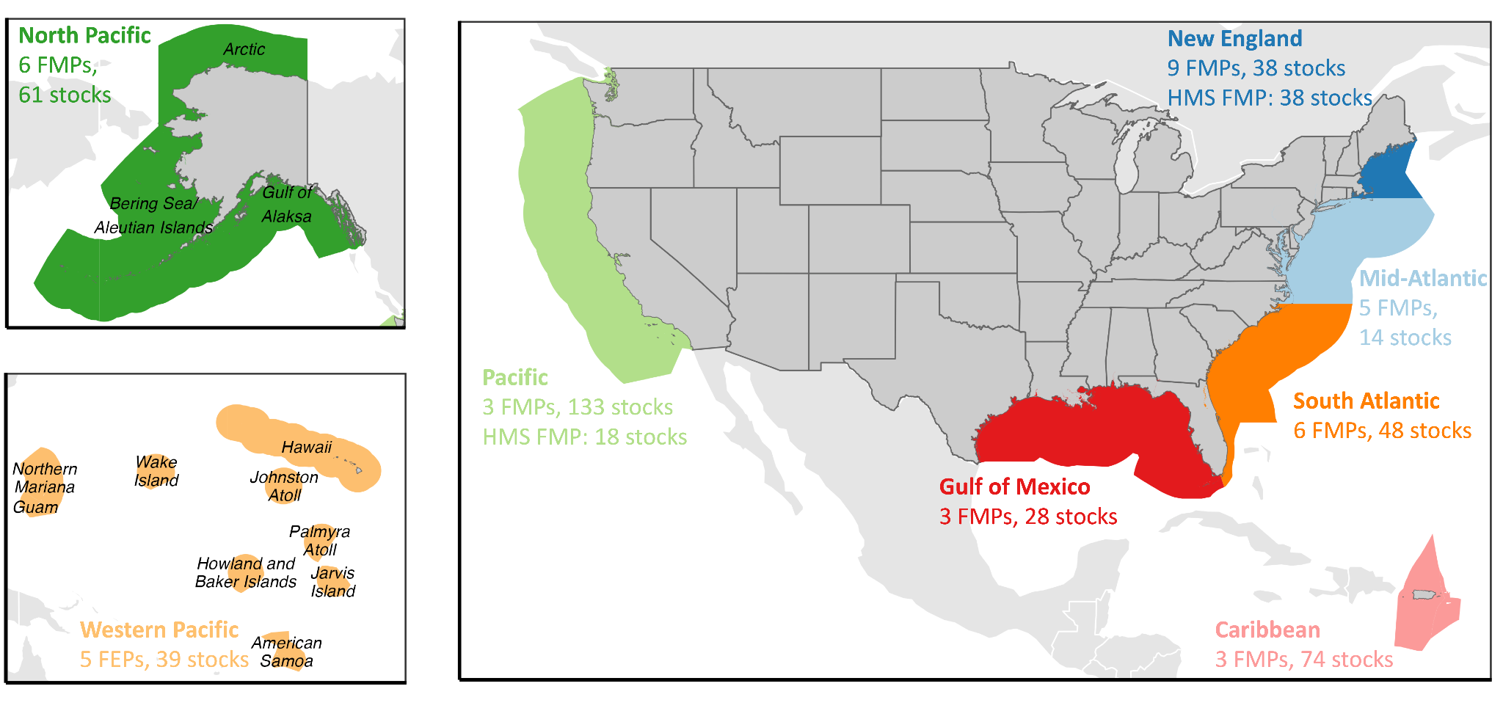

**Figure 1.** The jurisdiction of the eight U.S. regional Fishery Management Councils (FMCs), the number of Fishery Management Plans (FMPs) or Fishery Ecosystem Plans (FEPs) developed by each FMC, and the number of stocks managed by each FMC through these FMPs. The Atlantic and Pacific Highly Migratory Species (HMS) FMPs are developed by NOAA but are listed with the Pacific and New England FMCs.

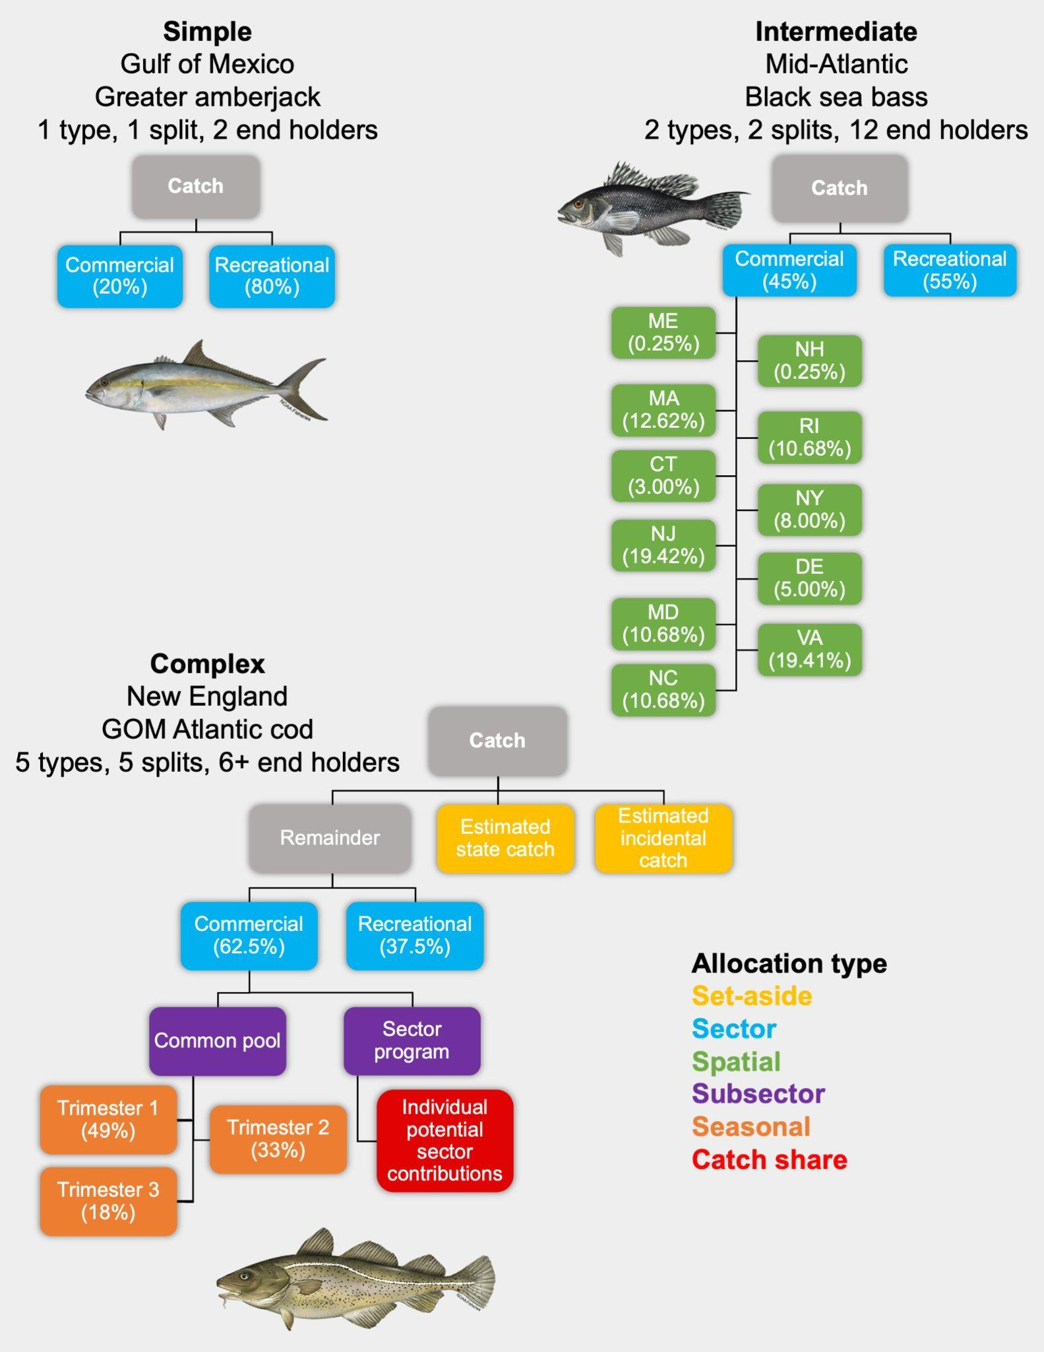

**Figure 2.** Flowcharts illustrating examples of quota allocation policies of low, medium, and high complexity. Box color indicates the type of quota allocation policy. Both of the illustrated “set asides” are forms of subsector allocations.

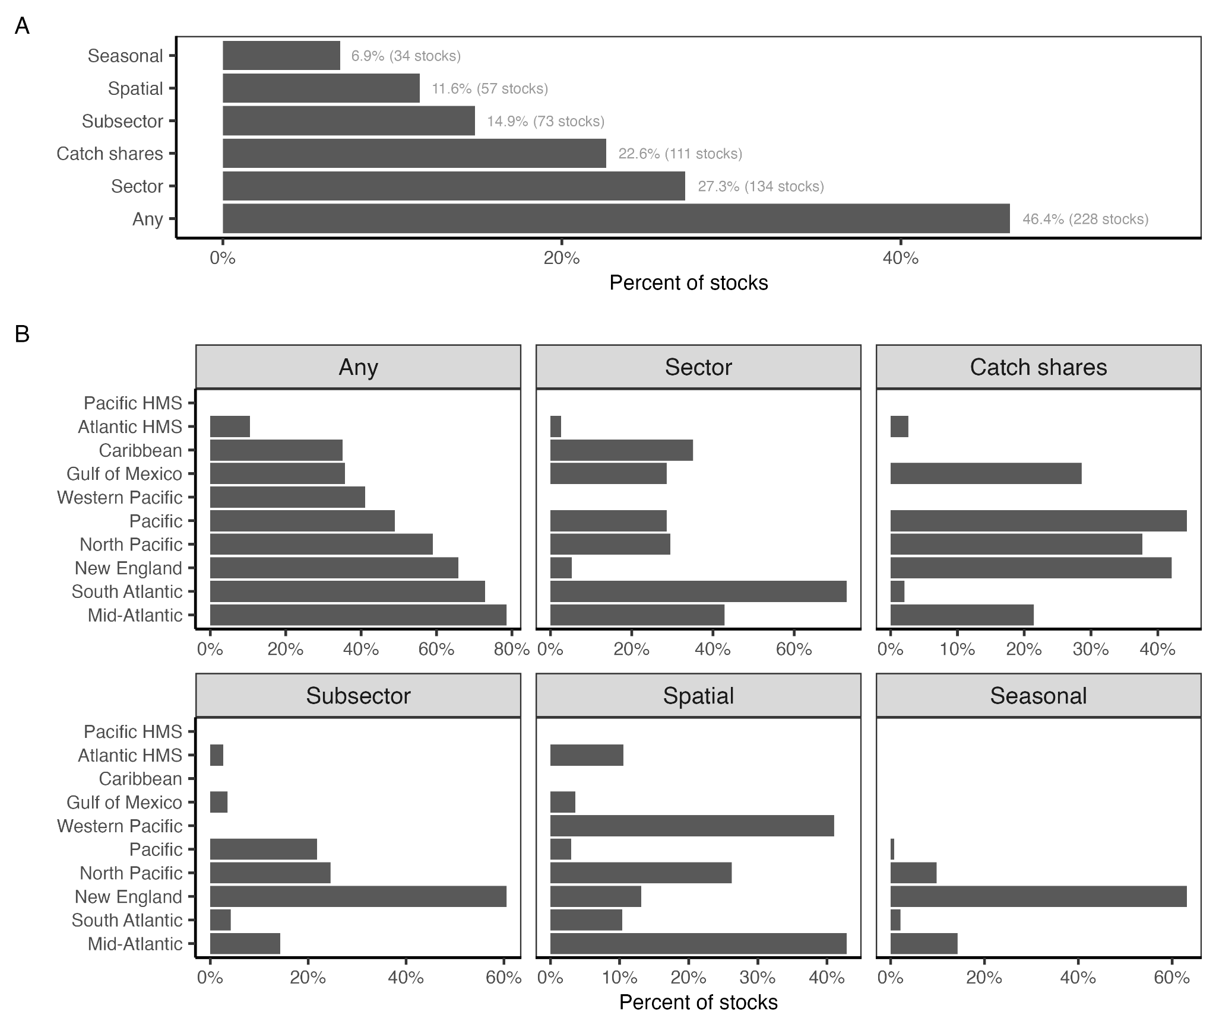

**Figure 3.** The percent of federally managed fish and invertebrate stocks managed using quota allocation policies **(A)** nationwide and **(B)** by regional Fishery Management Council.

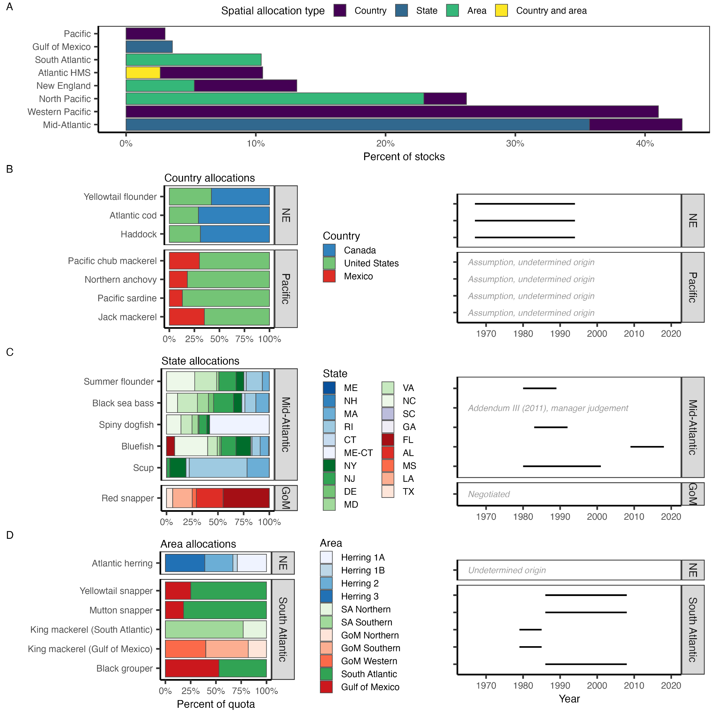

**Figure 4.** The (A) percent of stocks managed with spatial allocation policies by regional Fishery Management Council (FMC) and spatial allocation type and the percent allocations for stocks managed with (B) country-, (C) state-, and (D) area-based spatial allocation policies. In (C), color groups indicate the FMC representing each state: New England (blues), Mid-Atlantic (greens), South Atlantic (purples), and Gulf of Mexico (reds). In (D), color groups indicate the area scheme: herring zones (blues), South Atlantic king mackerel zones (greens), and Gulf of Mexico king mackerel zones (reds). The Atlantic bluefin tuna stock is managed by the Atlantic Highly Migratory Species (HMS) FMP using both country- and area-based spatial allocations.

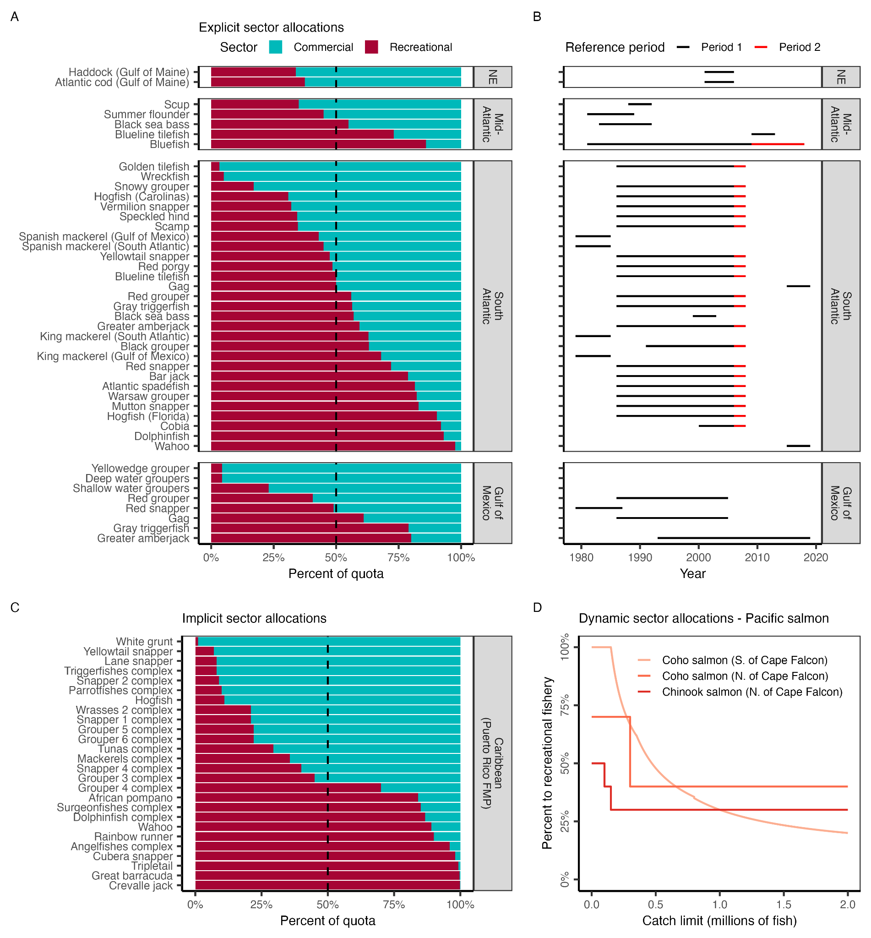

**Figure 5.** Sector-based allocation policies by regional Fishery Management Council (FMC). Panel **A** shows the percent of quota allocated to commercial and recreational fisheries by FMC and stock. Stocks are sorted in order of increasing allocations to recreational fisheries. The vertical dashed line indicates a 50:50 split. Panel **B** shows the reference period used to derive the allocation policy (lines). A few policies weigh the recent time period in addition to the selected reference time period. Panel **C** illustrates the implicit allocation policies resulting from setting fixed catch limits based on historical catch time series for stocks managed by the CFMC Puerto Rico FMP. Panel **D** shows the dynamic sector allocation policies used to vary sector allocations based on salmon stock size for stocks managed by the PFMC Pacific Salmon FMP.

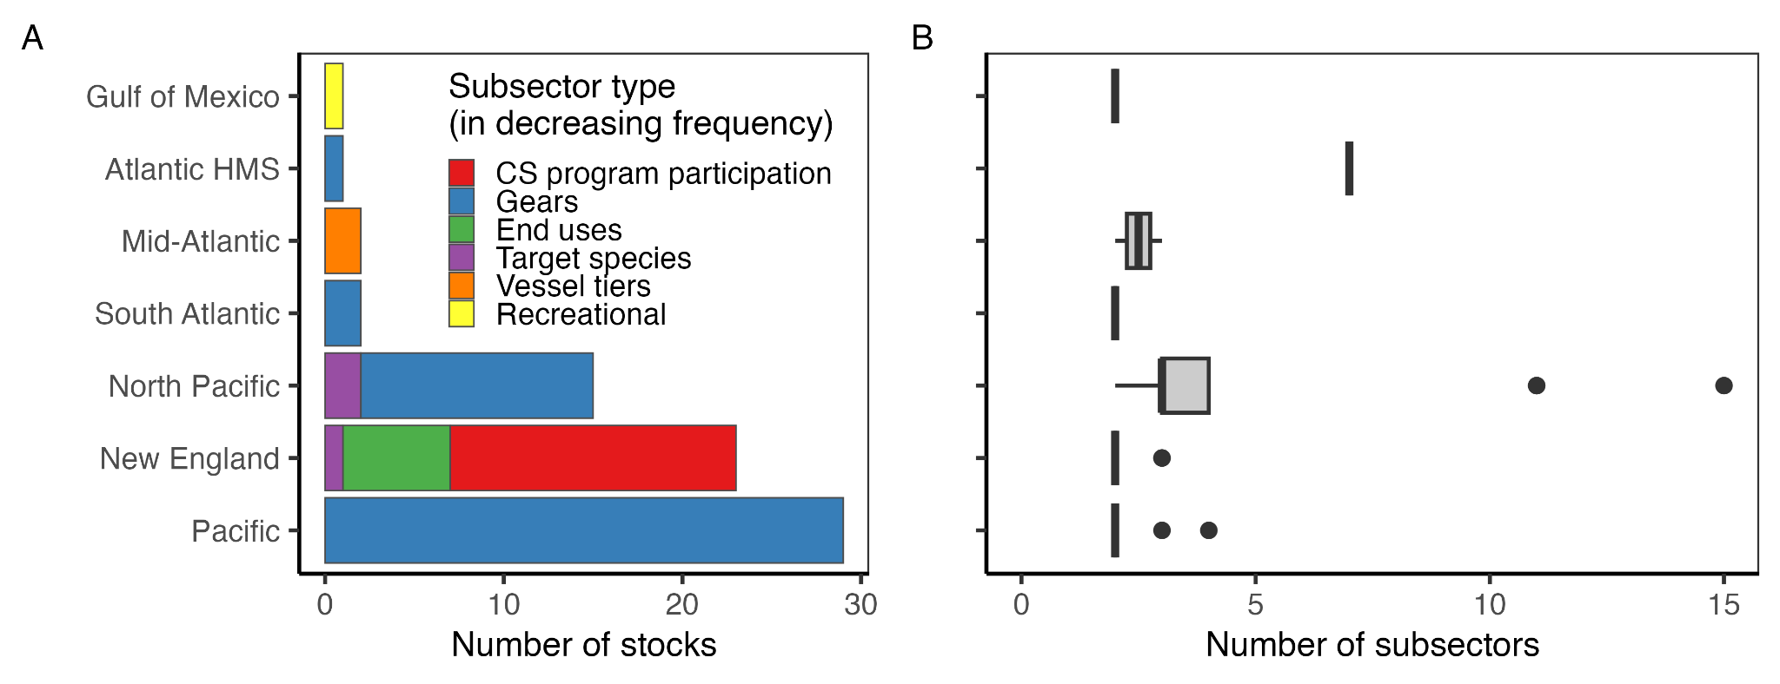

**Figure 6.** The **(A)** number of stocks managed using subsector allocations by regional Fishery Management Council (FMC) and subsector type and **(B)** number of subsectors included within the subsector allocation policies implemented by each FMC. In **(A)**, all but the “Recreational” subsector type are commercial subsectors. In the boxplots, the solid line indicates the median, the box indicates the interquartile range (IQR; 25th to 75th percentiles), the whiskers indicate 1.5 times the IQR, and points indicate outliers.

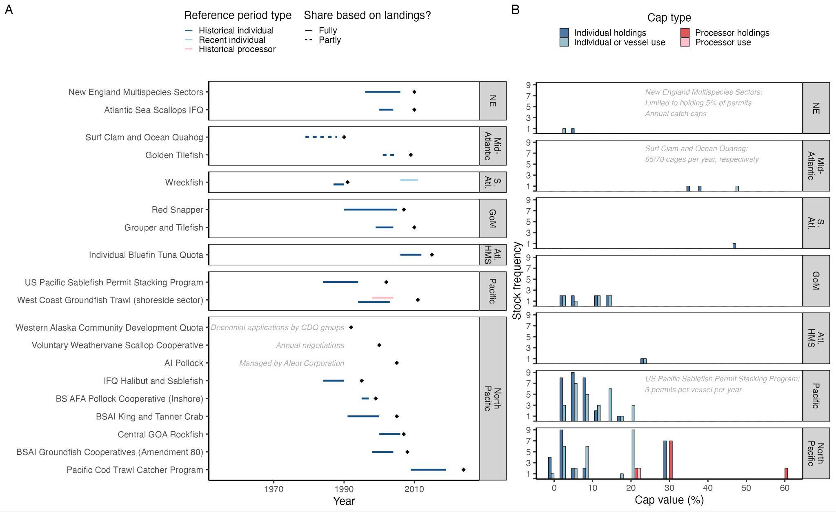

**Figure 7.** The **(A)** reference period and year of implementation (diamond) for allocations by program and regional Fishery Management Council (FMC) and **(B)** stock frequency distribution of holding and use caps by FMC. In **(A),** reference periods are colored by type (historical vs. recent, individual vs. processor). Programs with reference periods are sorted by implementation year. In 2012, inactive wreckfish quota was redistributed using a recent reference period (light blue). Dashed lines highlight programs in which shares are partly rather than fully based on landings (for Golden Tilefish, also depends on tier; for Surf Clam and Quahog, also depends on vessel size). Gray text explains protocol for programs that do not use landings to determine shares. Reference period can vary by species (New England Multispecies) and permit (Pacific Cod Trawl Catcher Program), therefore most common reference period is illustrated. In **(B)**, cap value frequencies are colored by cap type (holding vs. use, individual vs. processor). Protocol for programs with non percent-based caps described in gray text. Crew, catcher/processor, and cooperative caps are rare and therefore excluded. The Weathervane Scallop Cooperative, W. AK Community Development Quota, and AI Pollock do not employ caps, and are therefore excluded. Halibut is excluded from IFQ Halibut and Sablefish because it is managed by the International Pacific Halibut Commission. Bars are offset by 3 when necessary for visualization.

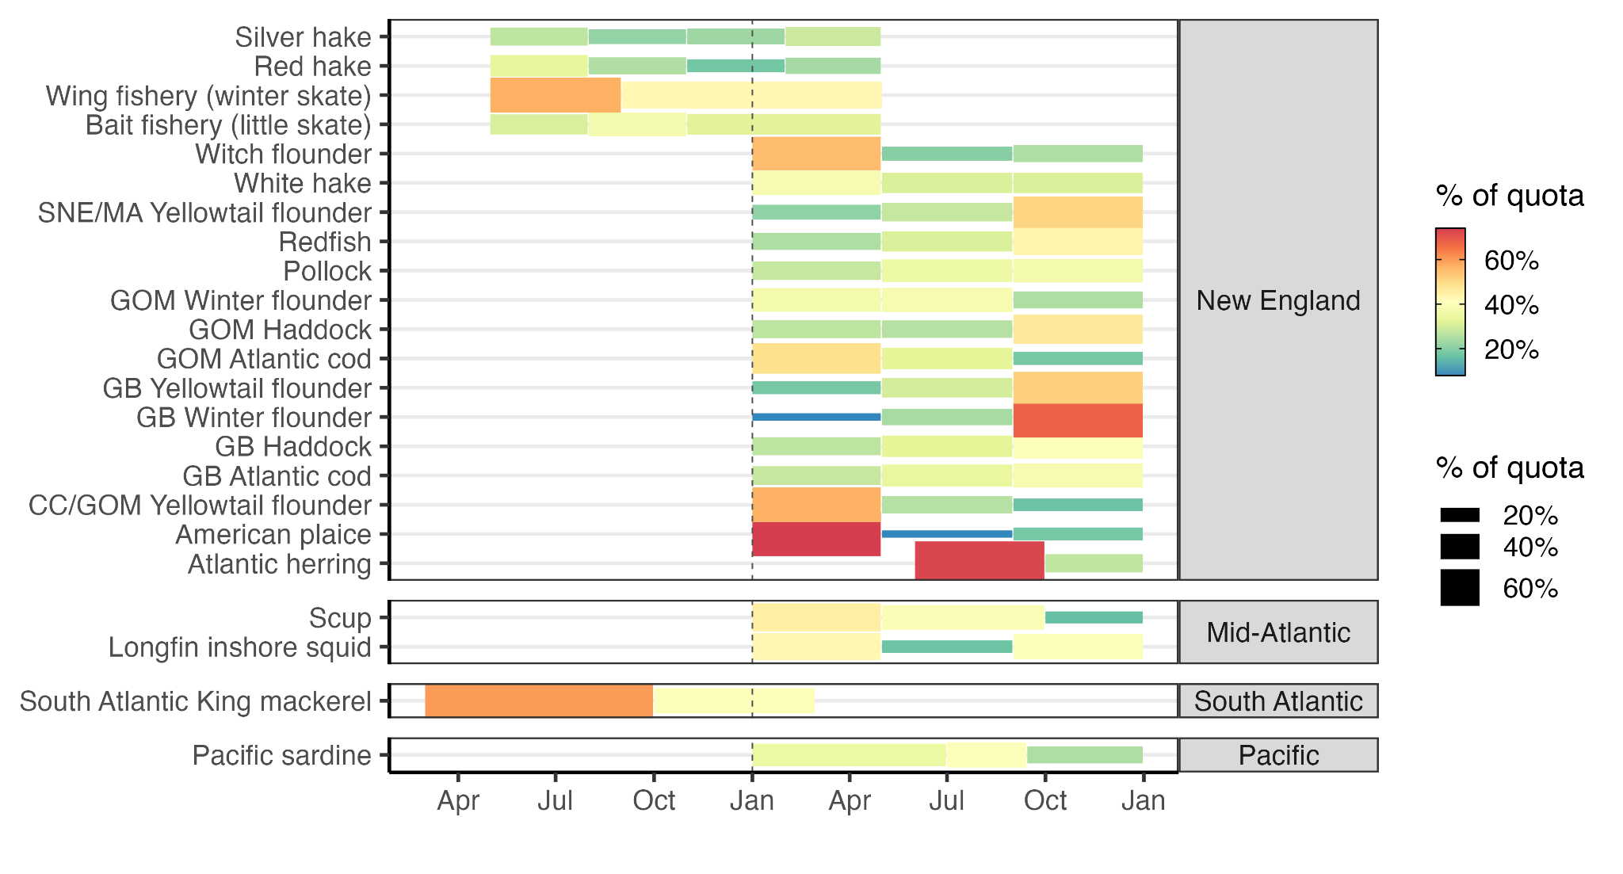

**Figure 8.** Seasonal allocations of stocks by regional Fishery Management Council. Blocks indicate the temporal extent of each season and block size and color indicate the percent of quota allocated to that season.

***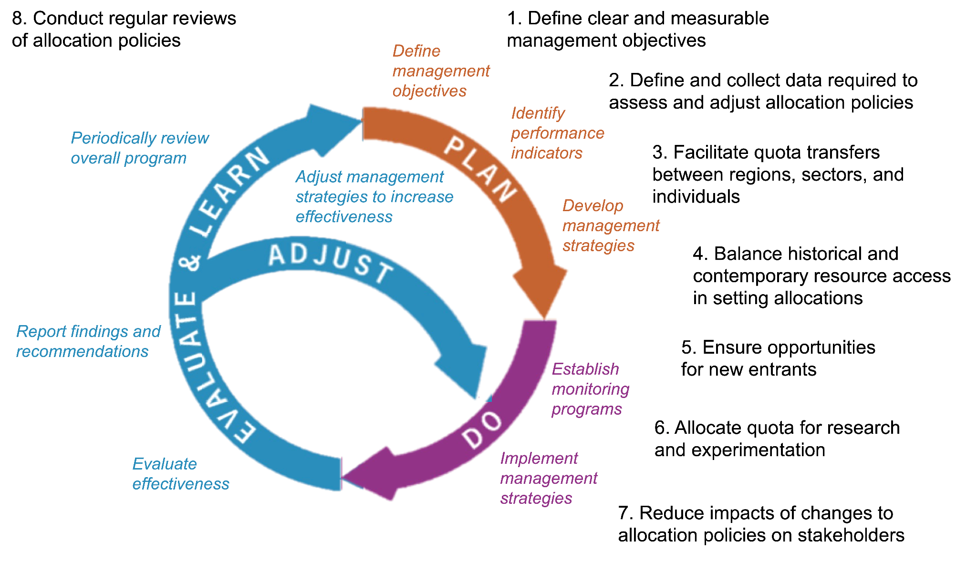*Figure 9.** A conceptual diagram illustrating the eight best practices (black text) for enhancing the adaptive management of quota allocation policies. The figure is adapted from Jones et al. (2005).

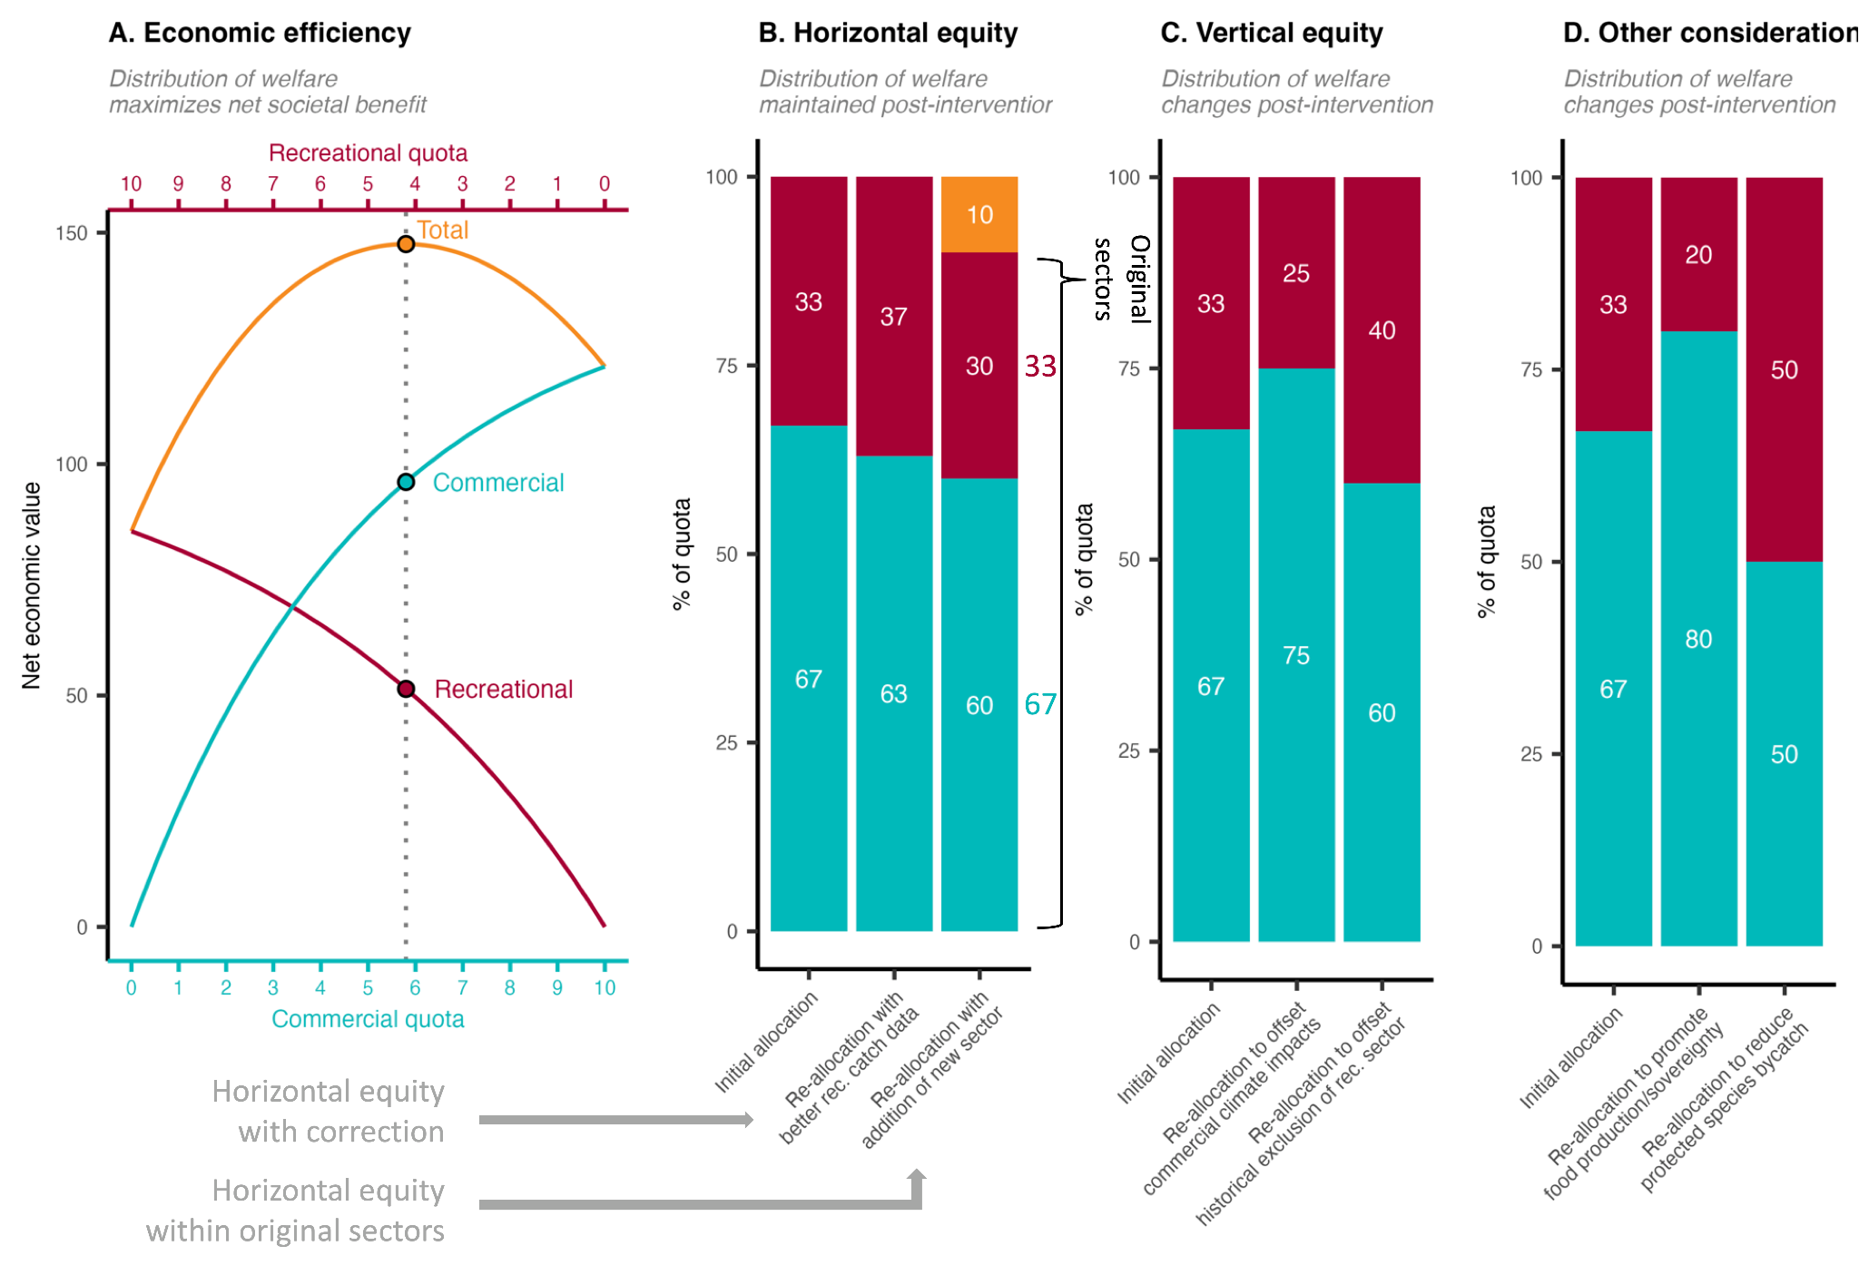

**Figure 10.** An illustration of alternative conceptualizations of equity in quota allocation policies. Panel **A** illustrates an allocation policy that seeks to optimize economic efficiency by maximizing the net economic benefits of commercial and recreational fisheries. The optimal policy is marked by the vertical dotted line. Panel **B** illustrates a suite of allocation policies that seek to maintain “horizontal equity” whereby the distribution of welfare remains proportional to historical levels. Column 1 shows the initial allocation based on historical catch. Column 2 illustrates a scenario in which the policy is updated with improved estimates of historical recreational catches. Although it results in a different distribution of welfare relative to the initial policy, it is motivated by the same goals (but uses better data) and is therefore still an example of horizontal equity. Column 3 illustrates a scenario in which a historically omitted subsistence sector (orange) is given access. The losses in allocation to the original sectors are proportional; thus, horizontal equity is maintained. Panel **C** illustrates a suite of allocation policies that seek to achieve “vertical equity” whereby the distribution of welfare changes after an intervention in a way considered more fair. This could be to compensate communities disadvantaged by historical allocations (column 2) or by the impacts of contemporary or future climate change (column 3). Panel **D** illustrates how managers could adjust allocation policies to achieve other fisheries objectives, such as promoting food production and sovereignty by prioritizing commercial fishing (column 2) or reducing bycatch of protected species by prioritizing more selective recreational fisheries (column 3). Although these adjustments change the distribution of welfare, they are not motivated by equity and fairness between sectors (though they do relate to broader societal concepts of fairness) and therefore do not qualify as vertical equity. We illustrate these concepts using sector allocations as an example, but all these concepts apply to any allocation between harvesting entities (states, subsectors, individuals, etc).

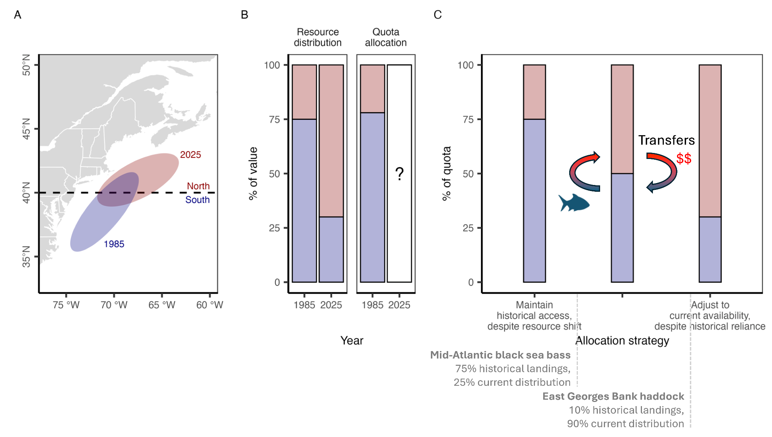

**Figure 11.** A conceptual schematic illustrating the spectrum of allocation options available to managers as stocks shift distributions and their availability to fisheries under climate change. Panel **A** illustrates the shift in distribution of hypothetical stock from 1985 to 2025 relative to a hypothetical management boundary. Panel **B** illustrates the proportional distribution of the resource between the two management zones in 1985 and 2025. The allocation of quota between the zones roughly matches the 1985 distribution because it was established based on 1980-1985 catch distribution. Managers must now decide whether and how to adjust the quota allocation given the climate-driven shift in distribution. Panel **C** illustrates the spectrum of options available to managers. On one end of the spectrum, managers could maintain historical access despite the resource shift. This protects historical access for southern zone fishermen but introduces inefficiencies, risks local depletion, and is unfair to northern zone fishermen. On the other end of the spectrum, managers could fully adjust to current resource distribution. This is efficient and aligned with conservation goals but does not protect historical dependence and is therefore unfair to southern fishermen. As a result, managers may wish to find a middle ground between these two extremes. Examples of allocation policies that fall in middleground are highlighted. Furthermore, allowing transfers between zones provides a mechanism for northern fishermen to gain access and for southern fishermen to be compensated for lost access.

### Supplemental Tables and Figures

**Table S1.** Fishery Management Plans (FMPs) and Fishery Ecosystem Plans (FEPs) used to manage U.S. federal fish and invertebrate stocks.†

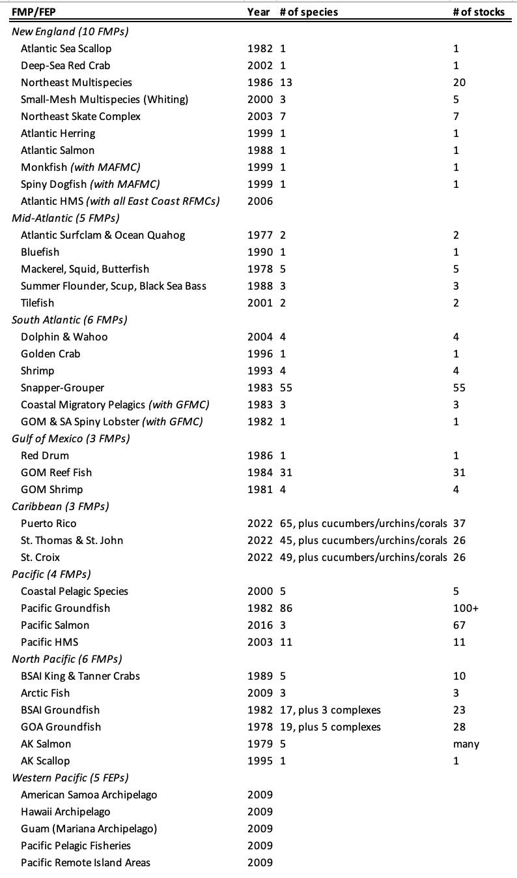

*† We did not evaluate the seven habitat-oriented FMPs because they do not manage marine fish or invertebrate fisheries: (1) New England: Habitat FMP; (2) South Atlantic: Coral and Sargassum FMPs; (3) Gulf of Mexico: Aquaculture, Coral, and Essential Fish Habitat FMPs; and (4) Pacific: Fishery Ecosystem Plan.*

**Table S2.** Structure of the quota allocation policy database.

|  |  |  |
| --- | --- | --- |
| **Description** | **Column name** | **Example** |
| Council | council | NEFMC |
| Management plan | fmp | Northeast Multispecies |
| Stock name | stock | Granger fish - Georges Bank |
| Species category | spp_catg | Groundfish |
| Common name | comm_name | Granger fish |
| Scientific name | sci_name | *Petrificus totalus* |
| Catch prohibited (yes/no)? | prohibited_yn | No |
| Allocation rule (yes/no)? | allocation_yn | Yes |
| Geographic rule (yes/no)? | spatial_yn | Yes |
| Country rule (yes/no)? | country_yn | Yes |
| List of countries | country_list | US, Canada |
| Number of countries | county_n | 2 |
| Country reference years | country_yrs | 1985-1990, 1995-2001 |
| State rule (yes/no)? | state_yn | Yes |
| List of states | state_list | ME, NH, RI |
| Number of states | state_n | 3 |
| State reference years | state_yrs | 1985-1990 |
| Area (yes/no)? | area_yn | Yes |
| List of areas | area_list | Georges Bank, Gulf of Maine |
| Number of areas | area_n | 2 |
| Area reference years | area_yrs | 1985-1990, 1995-2001 |
| Sector rule (yes/no)? | sector_yn | Yes |
| List of sectors | sector_list | Research, comm, rec, tribal |
| Number of sectors | sector_n | 3 |
| Basis (catch/effort) | sector_basis | Catch |
| Sector reference years | sector_yrs | 1985-1990 |
| Subsector rule (yes/no)? | subsector_yn | Yes |
| List of subsectors | subsector_list | Longline, gillnet, trap |
| Number of subsectors | subsector_n | 3 |
| Subsector reference years | subsector_yrs | 1985-1990, 1995-2001 |
| Seasonal rule (yes/no)? | season_yn | Yes |
| List of seasons | season_list | Jan - May, Jun - Dec |
| Number of seasons | season_n | 2 |
| Indiv/group rule (yes/no)? | indiv_yn | Yes |
| Basis (hist., equal, auction | indiv_basis | Historical catch |
| Reference years | indiv_yrs | 1985-1990 |
| Owner | indiv_owner | Vessel |
| Share caps (yes/no)? | indiv_caps_yn | Yes |

**Table S3.** Catch share programs by regional Fishery Management Council (FMC).

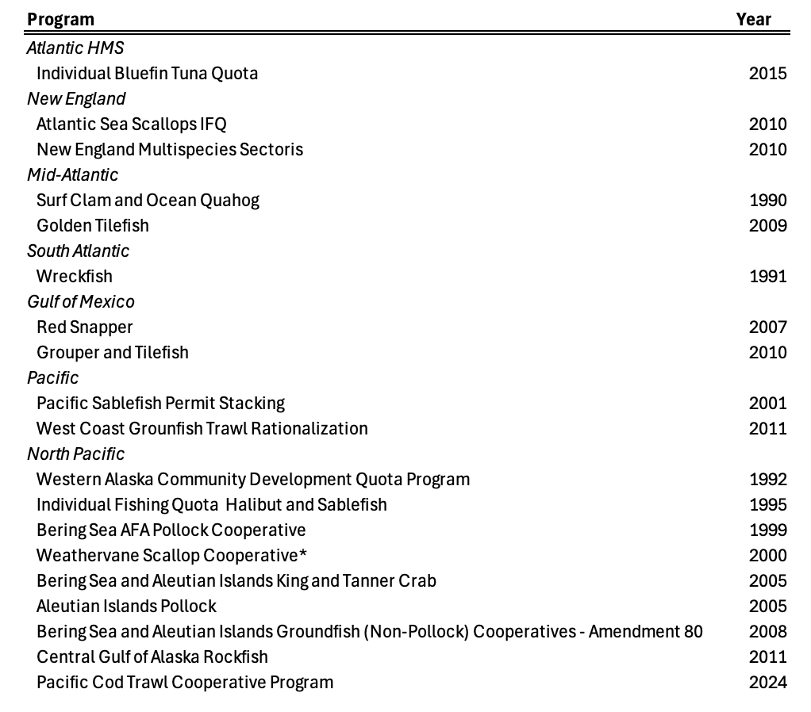

† The Weathervane Scallop Cooperative is a voluntary program and is not listed on the NOAA Catch Share website (https://www.fisheries.noaa.gov/national/sustainable-fisheries/catch-shares). Our inclusion of this program and the recently added Pacific Cod Trawl Cooperative Program is why we arrive at 19 rather than 17 catch share programs.

### 

**Figure S1.** Sector-based allocation policies documented by Morrison and Scott (2014). Panel **A** shows the percent of quota allocated to commercial and recreational fisheries by regional Fishery Management Council and stock. Stocks are sorted in order of increasing allocations to recreational fisheries. The vertical dashed line indicates a 50:50 split. Panel **B** shows the reference period used to derive the allocation policy (lines) and the year in which the allocation policy went into effect (points). A few policies weigh the recent time period in addition to the selected reference time period.

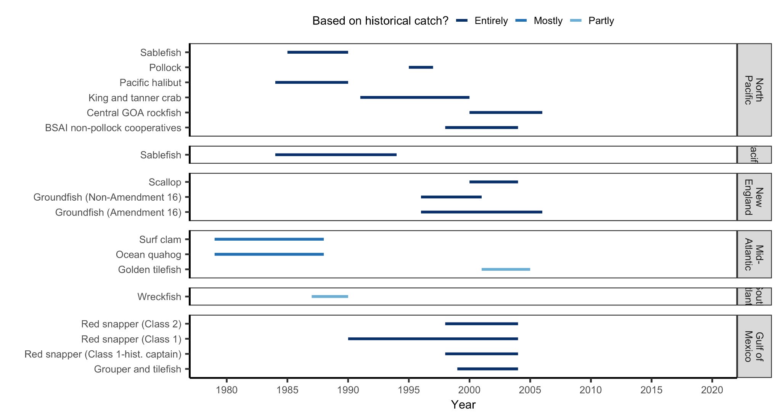**Figure S2.** Basis for catch share allocations documented by Morrison and Scott (2014).

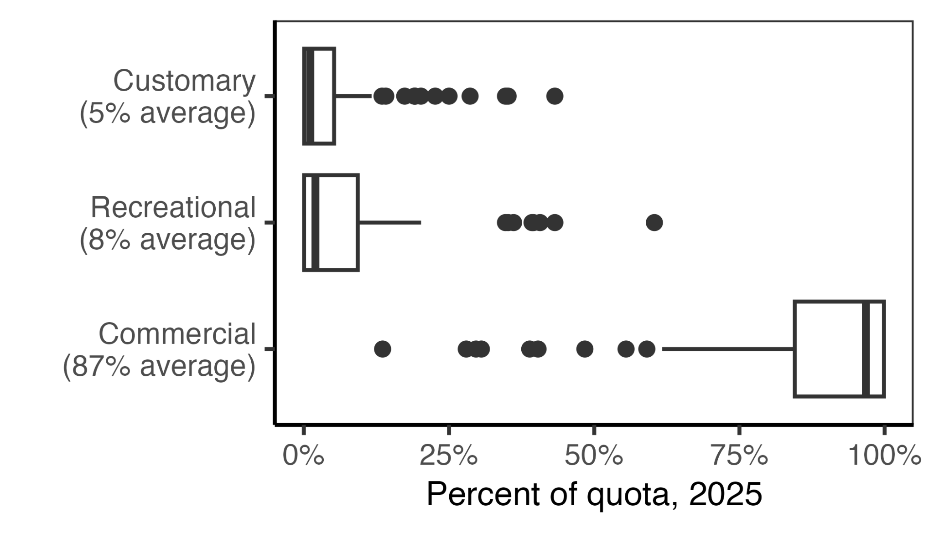

**Figure S3.** Quota allocation percentages among sectors for the 98 species managed within New Zealand’s Quota Management System in 2025 (Fisheries of New Zealand, 2024a). In the boxplots, the solid line indicates the median, the box indicates the interquartile range (IQR; 25th to 75th percentiles), the whiskers indicate 1.5 times the IQR, and points indicate outliers.